



Choose a Module

Choose Coursework Percentage **Individual Coursework**

**2022-23 Autumn**

**Student Name:** Enter your Full Name Here

**London Met ID:** E.g. 18053646

**College ID:** E.g. NP01MM0474747

**Assignment Due Date:** Click or tap to enter a date.

**Assignment Submission Date:** Click or tap to enter a date.

**Word Count: 242**

**Project File Links:**

|  |  |
| --- | --- |
| **YouTube Link:** | Keep Unlisted YouTube URL of your Project Here |
| **Google Drive Link:** | Keep Google Drive URL of your Project Here with Anyone in Organization can View Option Enabled |

*I confirm that I understand my coursework needs to be submitted online via MySecondTeacher under the relevant module page before the deadline in order for my assignment to be accepted and marked. I am fully aware that late submissions will be treated as non-submission and a marks of zero will be awarded.*



Choose a Module

Choose Coursework Percentage **Group Coursework**

**2022-23 Autumn**

|  |  |  |  |
| --- | --- | --- | --- |
| **Group Name:** | | | |
| **SN** | **Student Name** | **College ID** | **University ID** |
| **1** | **Dibbeshwor Acharya** | NP01BA4A220117 | 22067813 |
| **2** | **Roshani Karki** | np01cp4a220436 | 22067759 |
| **3** | **Sakchyam Thapa** | np01cp4a220185 | 22067800 |
| **4** | **Yogal Thapa Magar** | np01cp4a220189 | 22067804 |
|  | Enter your Full Name Here | E.g. NP01MM0474747 | E.g. 18053646 |

**Assignment Due Date: Thursday, February 3, 2023**

**Assignment Submission Date: Friday, February 3, 2023**

**Word Count: 242**

**Project File Links:**

|  |  |
| --- | --- |
| **YouTube Link:** | Keep Unlisted YouTube URL of your Project Here |
| **Google Drive Link:** | Keep Google Drive URL of your Project Here with Anyone in Organization can View Option Enabled |

*I confirm that I understand my coursework needs to be submitted online via MySecondTeacher under the relevant module page before the deadline in order for my assignment to be accepted and marked. I am fully aware that late submissions will be treated as non-submission and a marks of zero will be awarded.*

Contents

TABLE OF FIGURES 4

LIST OF TABLES 5

1. INTRODUCTION 1

1.1. Goals 1

1.2. Objectives 1

1.3. How HTML, CSS and JS was used 2

1.4. Verdict 2

2. DISCUSSION AND ANALYSIS 3

2.1. Text Editor 3

2.2. Wireframe tool 4

2.3. CSS used 5

2.4. Name of webpages 6

2.4.1. Homepage 6

2.4.2. Products Page 7

2.4.3. Feed Page 9

2.4.4. Blog 10

2.4.5. About Us 12

2.4.6. References 14

2.4.7. Feedback Page 15

3. TESTING 17

3.1. JavaScript Testing 17

3.1.1. Testing Form validation for feed-back Page 17

3.1.2. Testing “Rate Us:” emoji rating system 18

3.1.3. Testing slider in feed page 21

3.2. Navigation Hover Effect Testing 23

3.3. Internal and External Link Testing 24

3.3.1. Internal Link 24

3.3.2. External Link 26

4. CONCLUSION 28

5. APPENDIX 29

5.1. HTML 29

5.1.1. Home Page 29

5.1.2. Products Page 38

5.1.3. Feed Page 56

5.1.4. Blog Page 65

5.1.5. About Us 73

5.1.6. References 88

5.1.7. Feedback 96

5.1.8. CartPage 102

5.1.9. Technology Blog 108

5.1.10. Sub-Product Page 118

5.2. CSS 122

5.2.1. feedPage Style.css 122

5.2.2. feedback Page Style 126

5.2.3. Blog page style 132

5.2.4. cartPage Style 135

5.2.5. Header Style 138

5.2.6. Style (Sakchyam) 142

5.2.7. Portfolio Style 158

5.2.8. Style (Roshnii) 169

5.3. JavaScript 192

5.3.1. Feedback Page JS 192

5.3.2. Portfolio JS 194

5.3.3. Image Slider JS 196

5.3.4. CartPage JS 197

# TABLE OF FIGURES

Figure 1: Vs-code 4

Figure 2: Balsamiq wireframe 5

Figure 3: Homepage 7

Figure 4: homepage 2 7

Figure 5: Products Page 8

Figure 6: Products Page Wireframe 9

Figure 7: Feed Page 10

Figure 8: Feed Page wireframe 10

Figure 9: Blog page 11

Figure 10: Blog Page wireframe 11

Figure 11: About Us; Front Page 12

Figure 12: About us: CV 13

Figure 13: About us Front Wireframe 13

Figure 14: About Us individual Wireframe 14

Figure 15: Reference page 15

Figure 16: Refernce page wireframe 15

Figure 17: feedback Page 16

Figure 18: Feedback page wireframe 16

Figure 19: filling the form 18

Figure 20: Error message for incomplete form 18

Figure 21: lowest rating 19

Figure 22: Middle rating 20

Figure 23: Before next button 22

Figure 24: after next button 22

Figure 25: After previous button 23

Figure 26: hover effect in nav bar 24

Figure 27: Home to Products 25

Figure 28: Products to Home 25

Figure 29: Before opening link 27

Figure 30:External Link 27

# LIST OF TABLES

Table 1: Test1: Form Validation 17

Table 2: Test 2: emoji rating 19

Table 3: Test 3: Slider in Feed page 21

Table 4: Test 4: nav hover testing 23

Table 5: Internal Link Testing 24

Table 6: Testing External Link 26

# INTRODUCTION

This project aims at solidifying the basics of front-end web development among students. Our goal was to make an e-commerce site, a blog, portfolio for each team members and a feed-back form. Working on this project will help us be familiar with the basics of HTML, CSS and JavaScript, which are an integral part of web development.

Our websites name is Origin Bonsai. We have tried our best to make a well-functioning and cohesive website using what we know. It was not easy to put everything together and make the website look good. Every team member had their own ideas and aspirations, to homologate all those different ideas into a website was the most difficult part. But I am confident that our team has done their best and has created a website we all are proud of.

Our team members are Roshani Karkii, Sakchyam Thapa, Dibbeshwor Acharya and Yogal Thapa Magar. Roshani designed the products page, blog page. Sakchyam the Homepage and about us section. Dibbeshwor designed the feed page, feed back page, reference page and the cart page.

## Goals

The main goal of this project is to make a e-commerce website with a blog, feed-back page and portfolio using vanilla JavaScript, HTML and CSS. We are not allowed to use any frameworks or libraries. This is to help us learn the fundamentals of how HTML, CSS and JavaScript works before diving into the more advance stuff. The website must be easy to navigate and lead to sales of bonsai. The product page must be intuitive and lead to sales of bonsai plants.

## Objectives

The objectives of this project are quite straightforward, to make a cohesive and intuitive e-commerce website. The website needs to have an easily understandable interface that even a beginner can use. We need to make sure that there is uniformity in interaction throughout the website. We have decided to implement a slider in the feed page that cycles through the various posts. The cart page itself is a dummy page but when buy now is clicked, the number in the cart increases, indicating that a product has been added. A function form is also implemented in the feedback page.

## How HTML, CSS and JS was used

HTML stands for Hypertext Markup Language.HTML was used to provide the webpages a basic structure. It was used to separate the content, make navigation bars for forms, add buttons, sentences, paragraphs, photos, and icons, among other things. HTML5 was employed while working on this project. HTML is like a skeleton of a website, giving it structure.

CSS stands for Cascading Style Sheet. CSS was used to regulate the formatting, organization, and presentation of the webpages. It is used to give the website style. It is in charge of the stylistic work done on the homepage, including the background color, image size, placement of the contents, font family, font style, and many other things. This project uses inline, internal, and external CSS. Internal CSS was used on components that required separate styling on different pages, while external CSS was used on elements that were shared by all five web pages. If HTML is a skeleton, CSS is the flesh and dress of a website.

JS stands for JavaScript. JS was utilized in this project to regulate the behavior of various website elements. It is in charge of the webpage’s alert message popups, image slider, and form validation. In this project, JS from both internal and external sources is employed. JS is like the brain of a website, giving it logic and functionality.

## Verdict

As this project is only a simple E-commerce website prototype, using HTML, CSS, and JavaScript was sufficient to finish it. HTML, CSS, and JS alone wouldn’t be sufficient for a real-world project because doing so would be time-consuming and occasionally annoying.

Numerous issues plagued us, including images that covered the text, material that wasn’t correctly centered, extra space between the contents, JS that couldn’t get the value of the form box, etc. We were able to identify my errors and find solutions to all of those issues,

# DISCUSSION AND ANALYSIS

## Text Editor

Text editors are programs or word-processing software used to input and edit content. Text editors include, but are not limited to, WordPad, Notepad, Notepad++, Sublime Text, etc. (TechTerms.com, 2022).

For this project, the text editor of choice is Visual Studio Code, an IDE (Integrated Development Environment) program. Compared to other text editors, it is quite helpful since it has many features like prettier, which is a code formatter that neatly formats the code and makes it seem beautiful, go live, which enables editing HTML and seeing real-time changes without refreshing the browser.

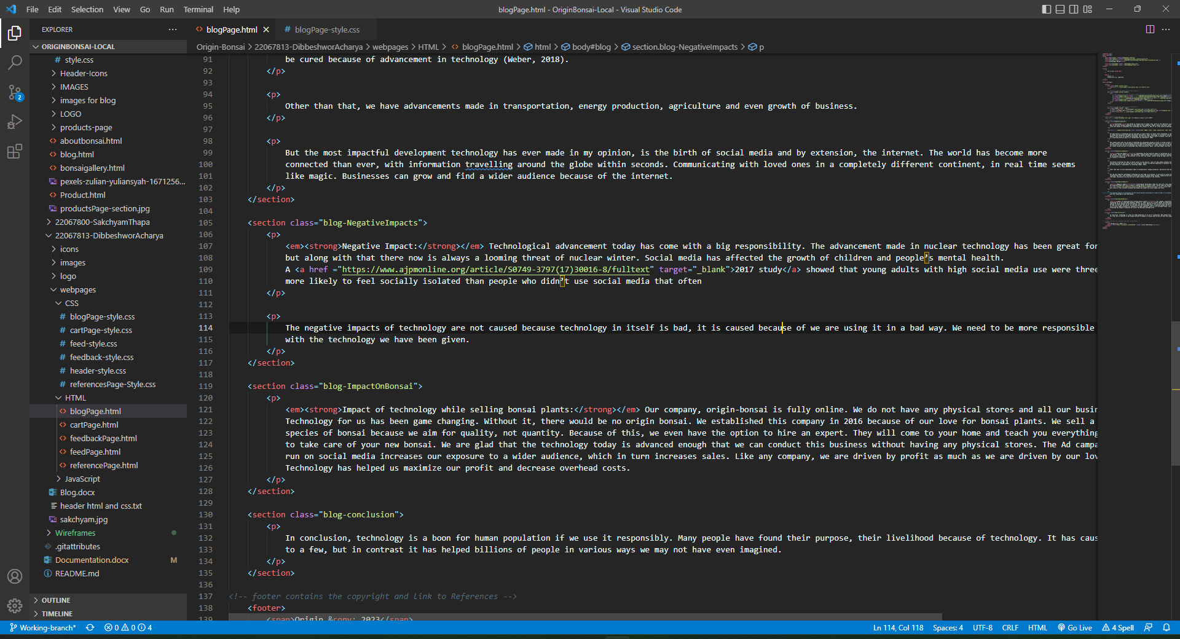

Figure 1: Vs-code

## Wireframe tool

When designing a website at the structural level, a wireframe tool is employed. Before adding visual layouts and content, they are used in the early stages of website development to create the fundamental framework of a page. (ExperienceUX, 2021).

The wireframe of the webpages in this project were designed using Balsamiq Wireframe. It is incredibly user-friendly and all the functions are simple to use which was really helpful for beginners like us. Having a wireframe tool to pre-design your website roughly was really helpful.

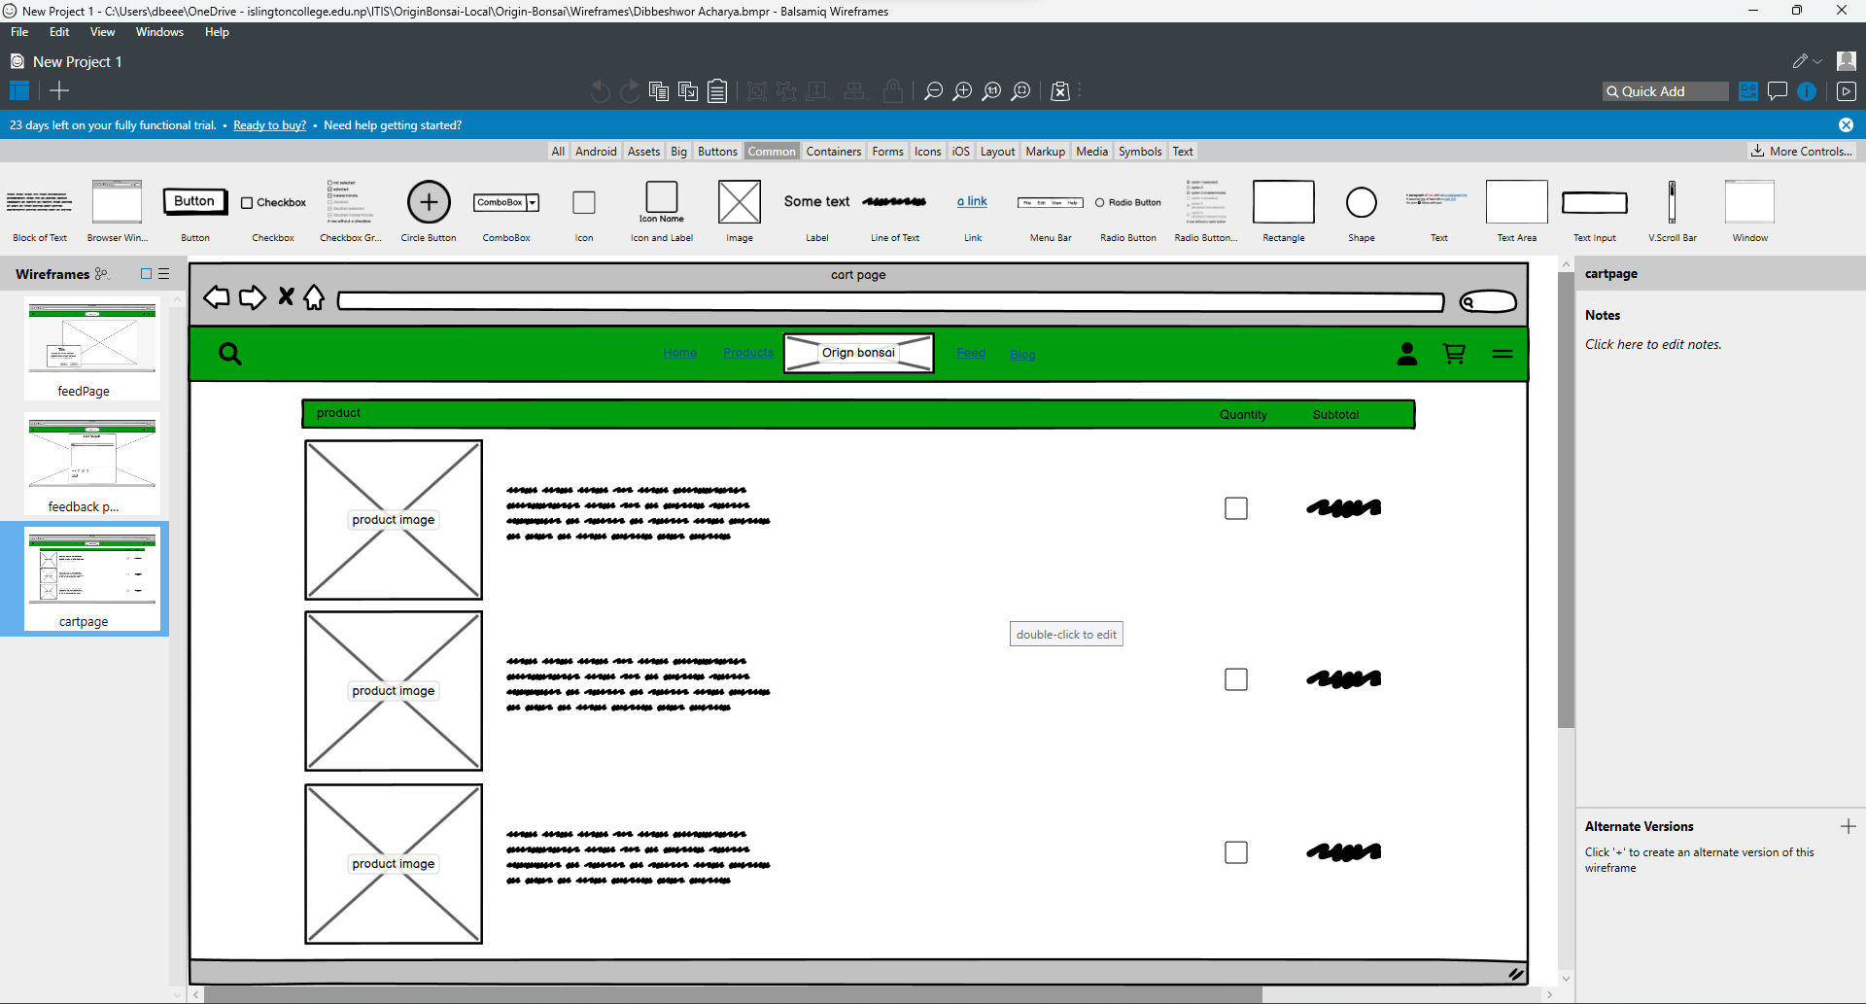

Figure 2: Balsamiq wireframe

## CSS used

The properties of CSS used in the project are as follows:

• Display: indicates how an element will be shown; display: flex was mostly utilized in the project.

• Flex-direction: indicates the direction of elements inner a flexbox.

• Width: used to determine the breadth of an element.

• Background: used to set the picture or backdrop color.

• Height: used to determine the height of an element.

• Font-weight: used to indicate how bold a text would be.

• Color: used to determine the text’s color.

• Text-align: used to modify the alignment of text.

• Z-index: used to indicate stack order of elements; element with greater zindex is always on front; its default value is 1.

• Opacity: used to change the clarity of an element.

• Flex-basis: indicates the initial length of flexible item.

• Margin: sets the margin of an element, which controls the container's outside space.

• Padding: sets padding for a component that occupies the container's inside area.

• Box-shadow: used to provide shadow to an element box.

• Align-items: indicates the alignment of element inside the flexbox.

• Justify-content: aligns the flexible container's contents when they don't occupy the entire horizontal area.

• -webkit-text-stroke: provide stroke to the text.

• Border-radius: indicates the radius of the border.

• Font-size: indicates the size of the font.

• Line-height: indicates the height of each line.

(W3School,2023)

## Name of webpages

### Homepage

The project's home page is its primary page. When the project is opened, this page is the one that loads initially. A quick overview of the whole e-commerce website, including some of its services, is provided on this page. It includes the categories of bonsai available along with our features.

Major tags used:(style, nav, meta, header, div , img, a, section, li, button, footer, hr, script, input, br)

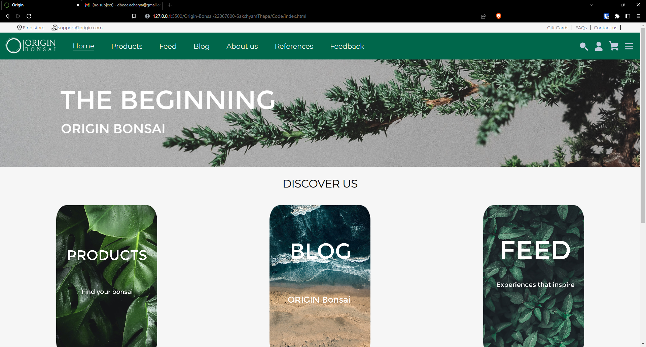

Figure 3: Homepage

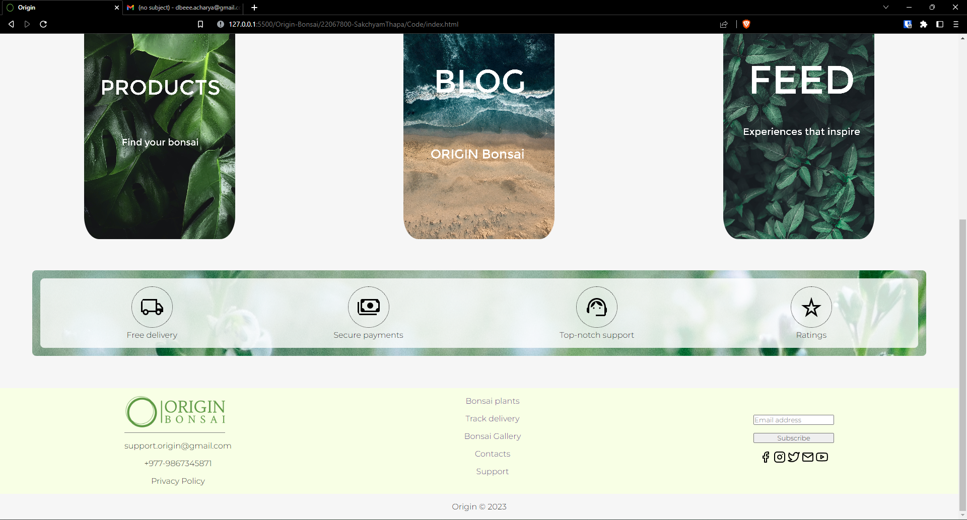

Figure 4: homepage 2

The wireframe for homepage is given below:

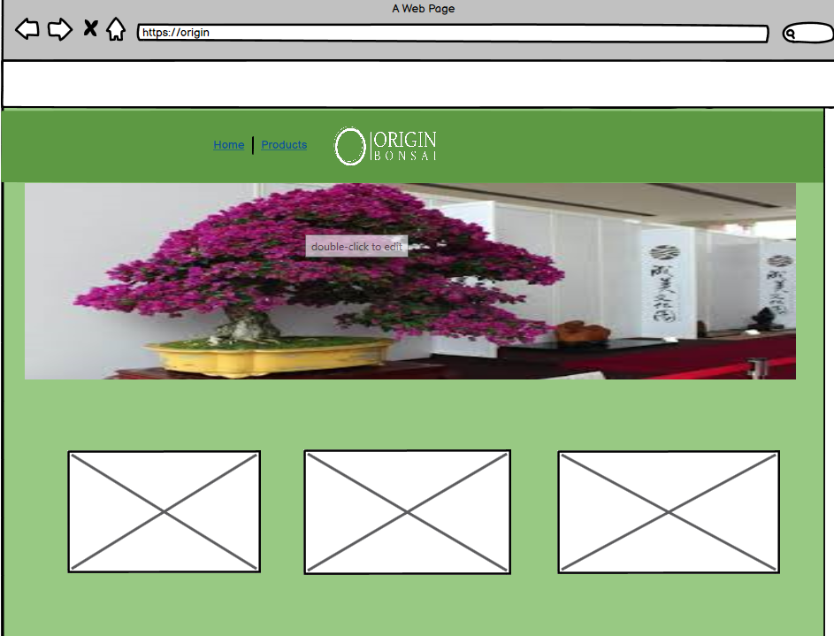

Figure : Homepage WireFrame

### Products Page

This page includes descriptions of all product categories and the items themselves that are available in the store, along with their names, prices, and descriptions.

Major tags used: (style, meta, nav, header, div, img, a, ul, li, button, footer, br, input, form)

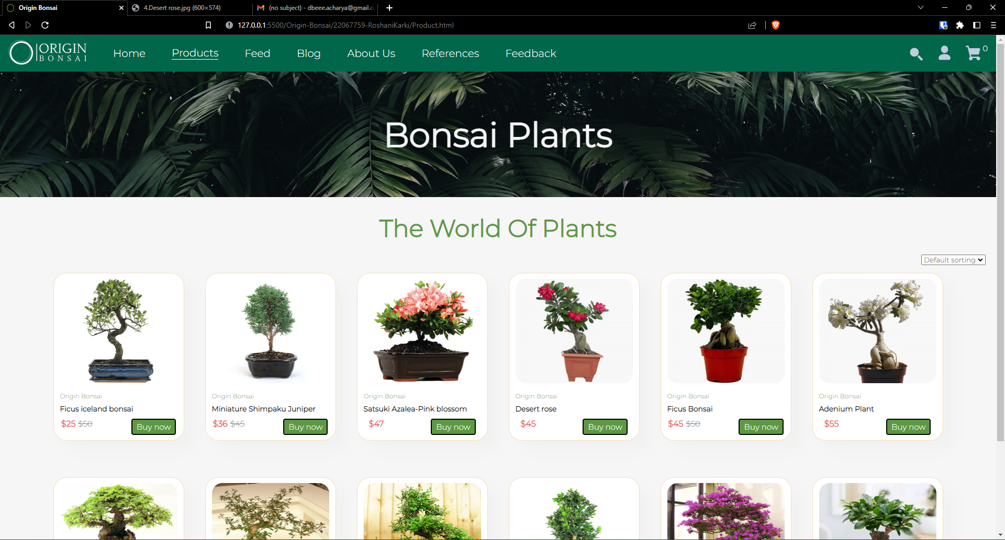

Figure 6: Products Page

Products page wireframe:

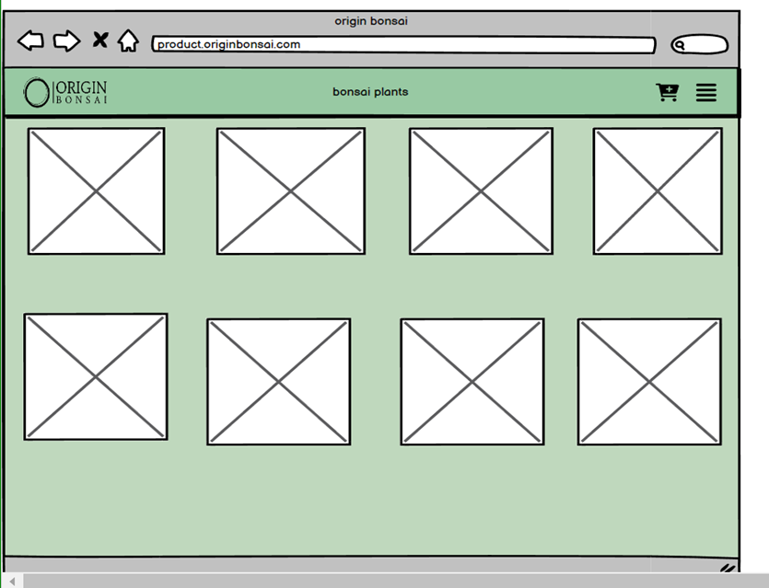

Figure 7: Products Page Wireframe

### Feed Page

This page was designed to accommodate the various stories our clients might have with their bonsai plants. It contains a short title with the image of the bonsai. A javaScript slider has been implemented in this page.

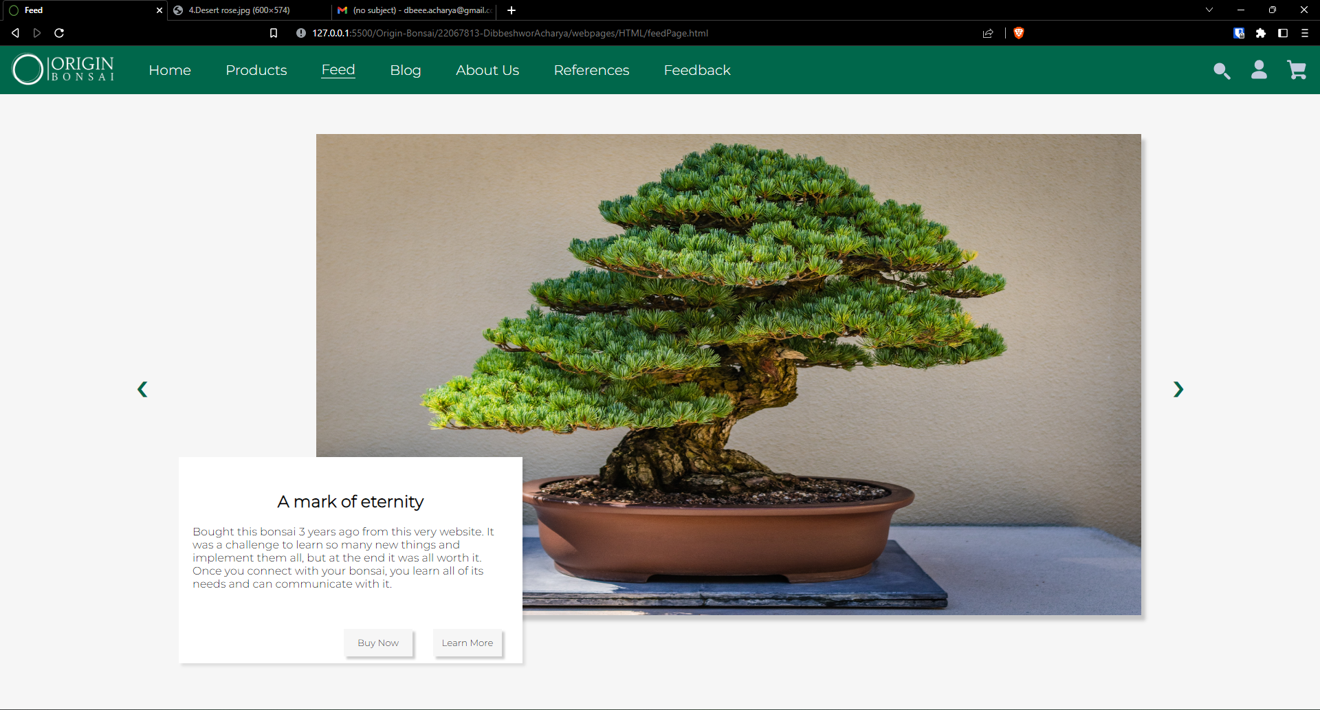

Figure 8: Feed Page

The wireframe for this page is given here:

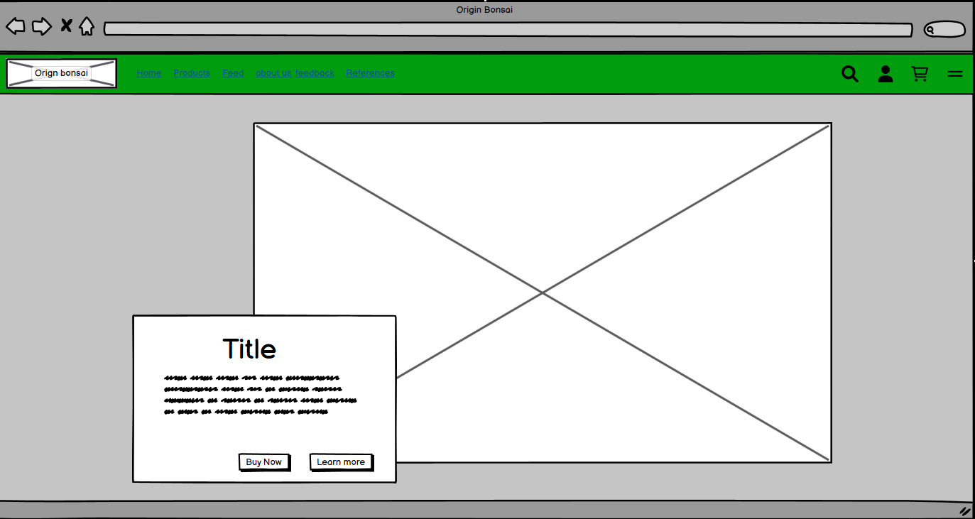

Figure 9: Feed Page wireframe

### Blog

This page contains various blogs written by our team, the highlight blog being about technology and bonsai. This page was designed to look a little random and playful because it is supposed to be a place to write our thoughts. There are three blogs in this page and also a bonsai gallery which contains a number of pictures of bonsai plants.

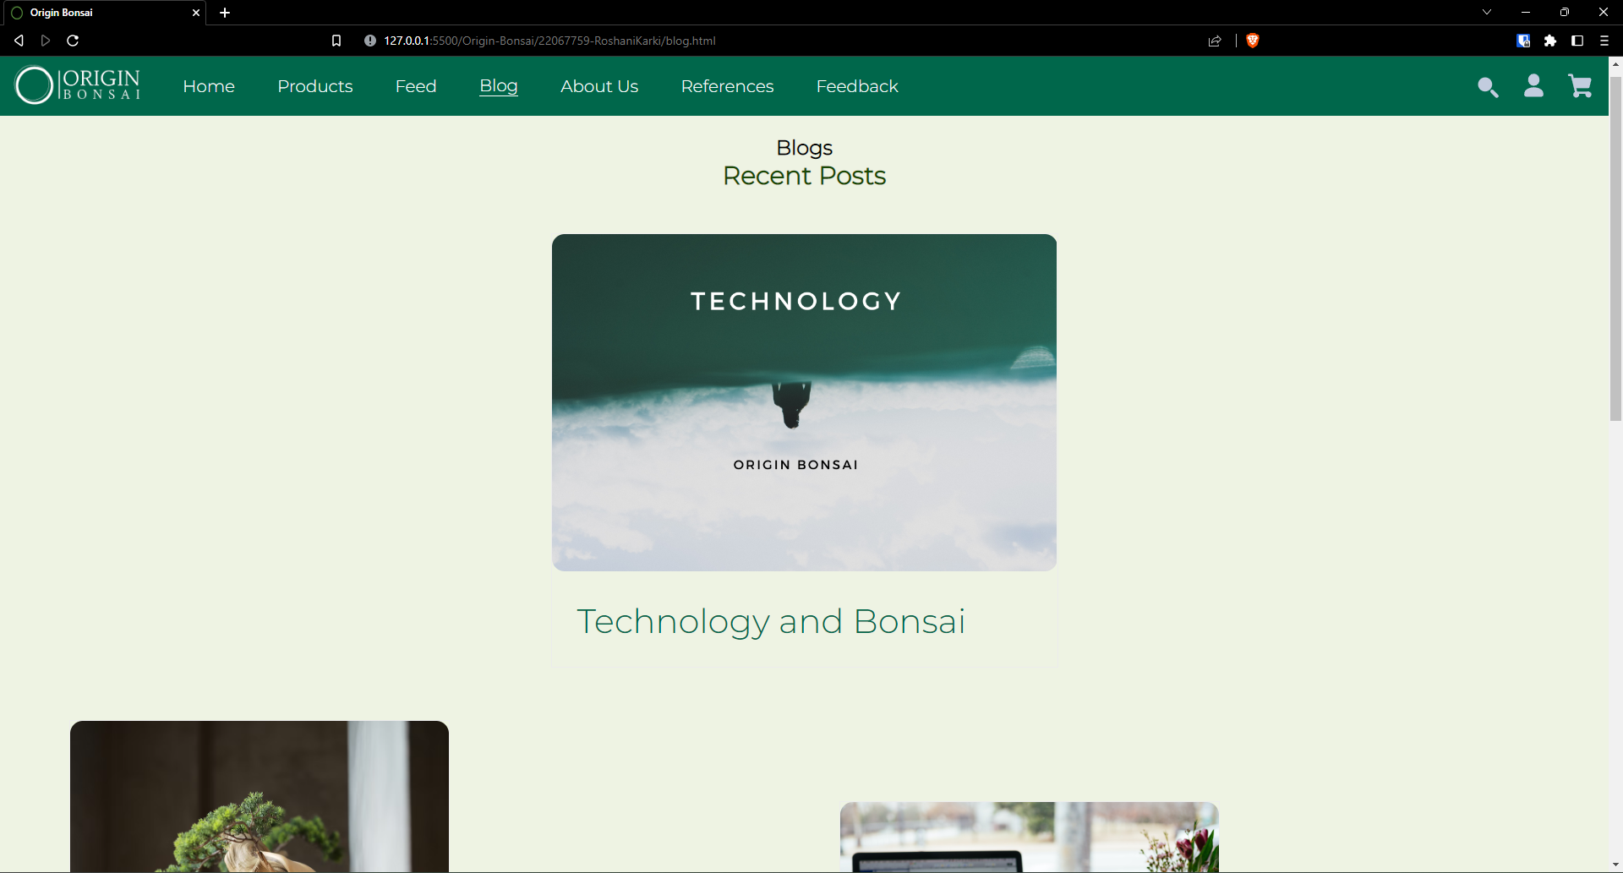

Figure 10: Blog page

The wireframe for blog page is:

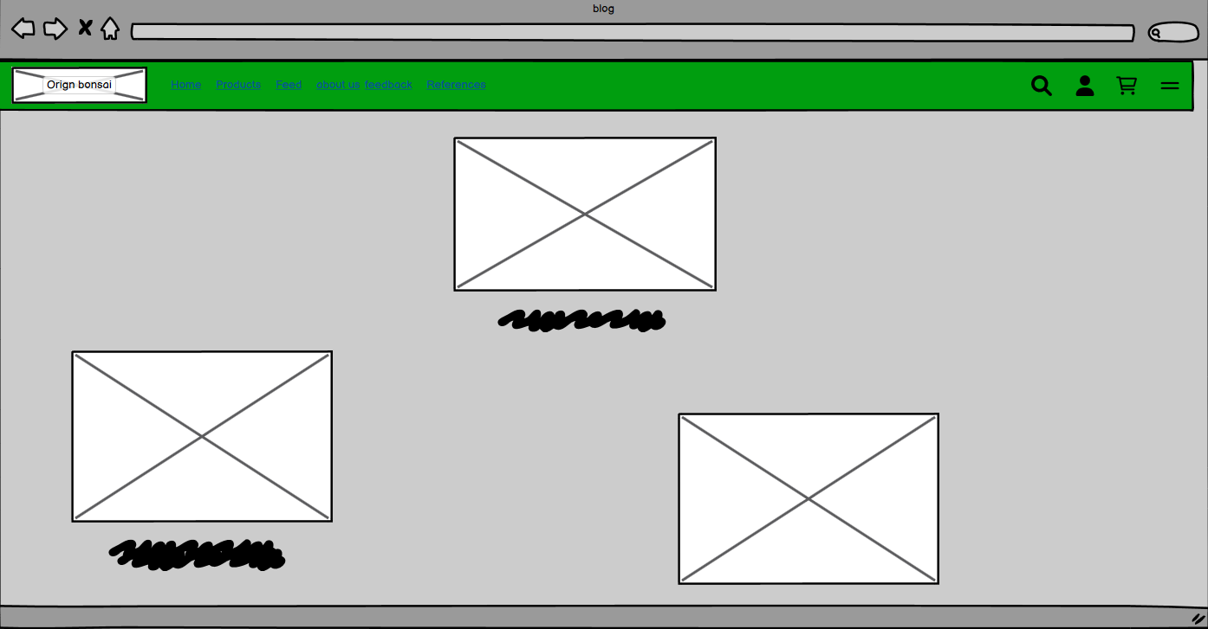

Figure 11: Blog Page wireframe

### About Us

The about Us page contains a detailed portfolio of each of our team members. We have tried to make this page unique and pleasing. The front page contains image and a very brief description of each member, when the image is clicked a bigger page opens which reveals the entire portfolio.

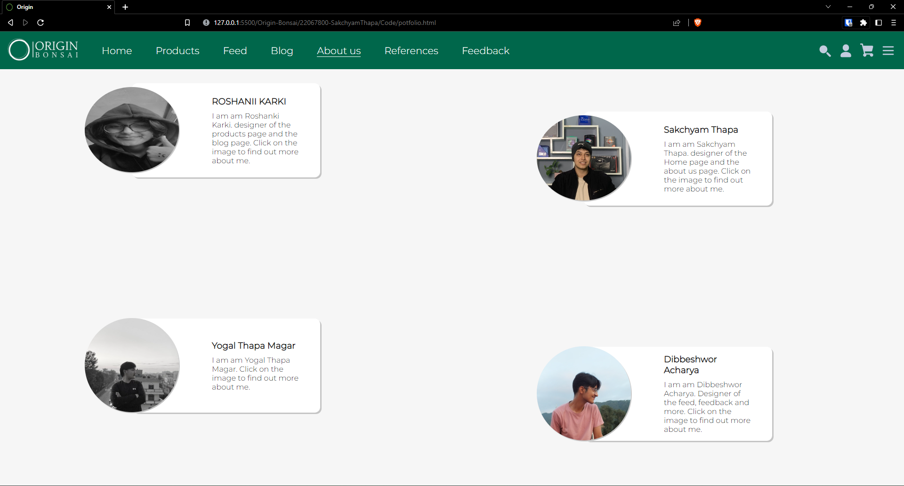

Figure 12: About Us; Front Page

Now, if I click on Roshni’s image a bigger cv opens

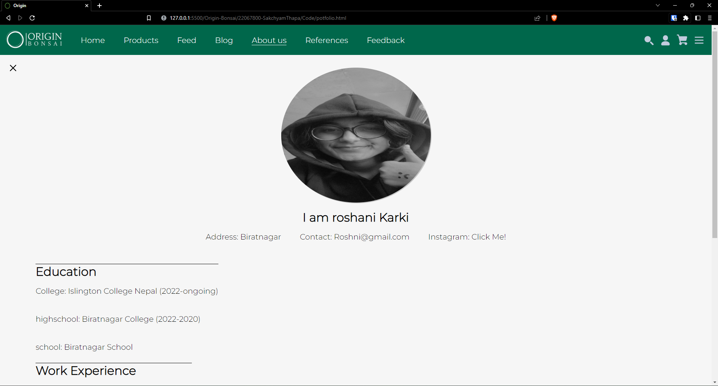

Figure 13: About us: CV

Wireframe for the front about us page:

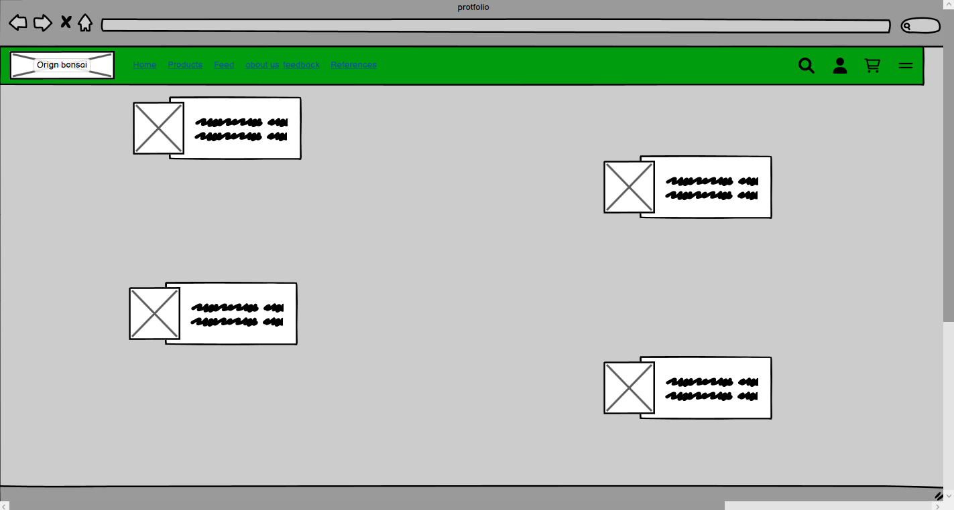

Figure 14: About us Front Wireframe

Wireframee For individual About US page:

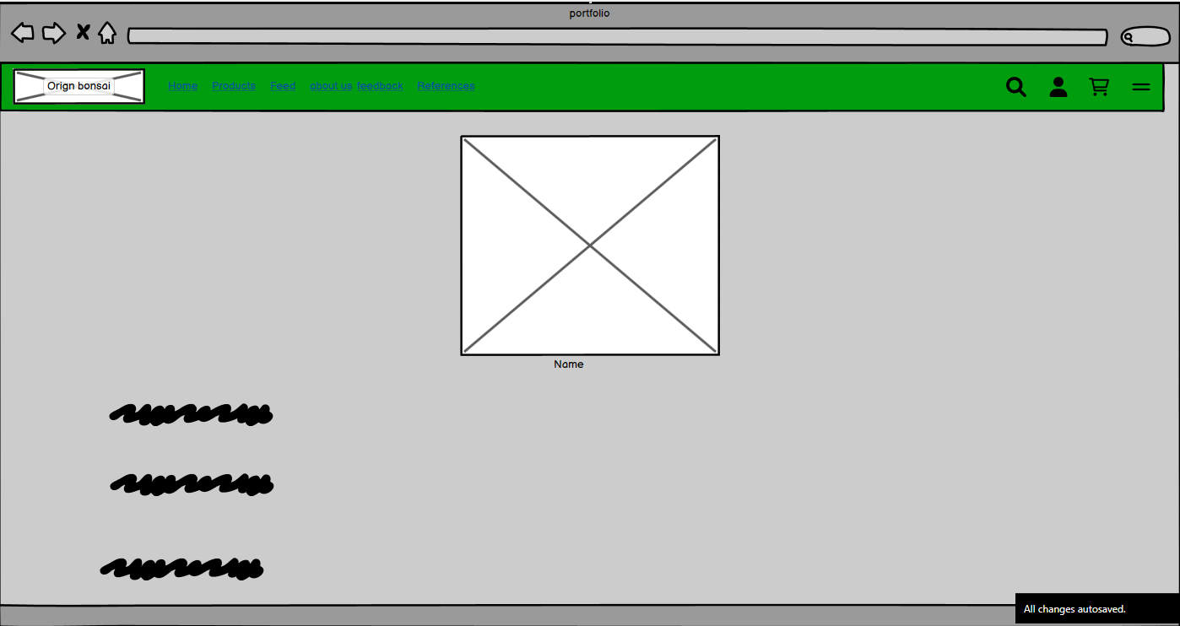

Figure 15: About Us individual Wireframe

### References

References page contains the comparison between the page we have taken inspiration form and our implementation of that idea. We have given a short text that explains the contrast between the two webpages. Hover effect has been used in each of the images to make it easier for the user to see the image in detail.

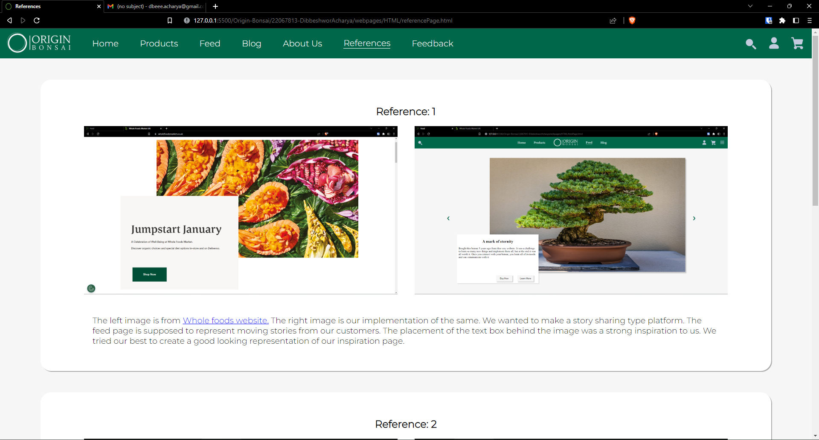

Figure 16: Reference page

Wireframe for the reference page is given below:

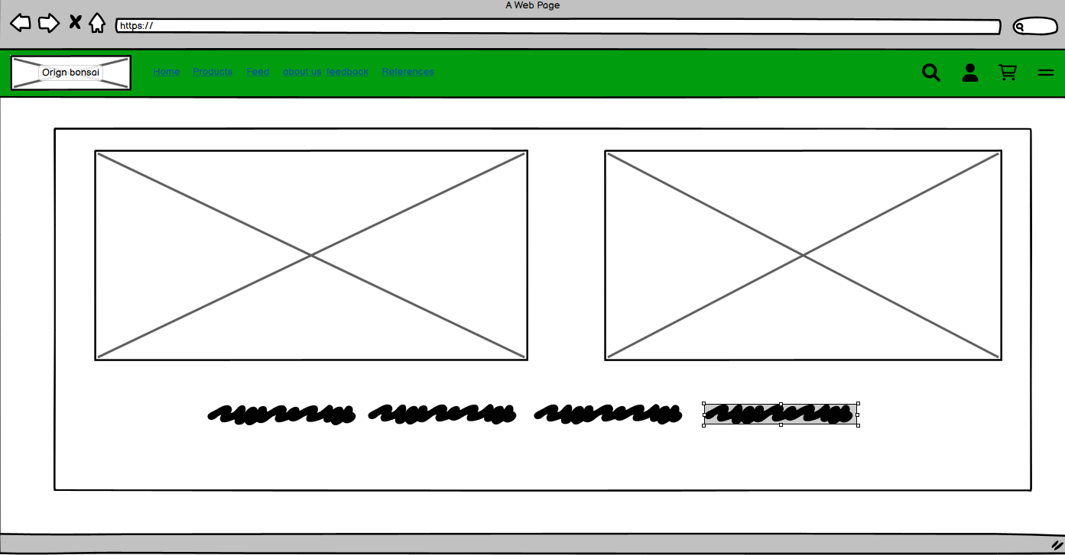

Figure 17: Refernce page wireframe

### Feedback Page

Feedback page as its name contains a feedback form for the user. There is a input field for name, email and a text area. We have also implemented an emoji rating system using JavaScript. The form is also validated before we submit it, which means that the user cannot submit the form with any field empty.

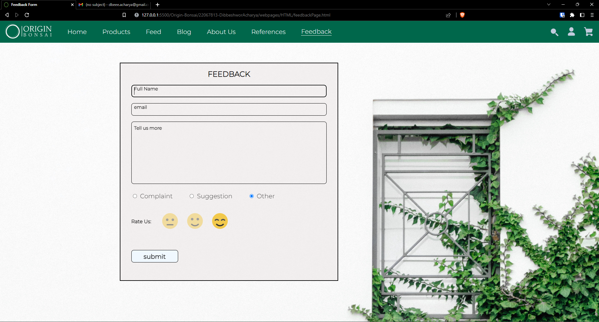

Figure 18: feedback Page

The wireframe for this page is given below:

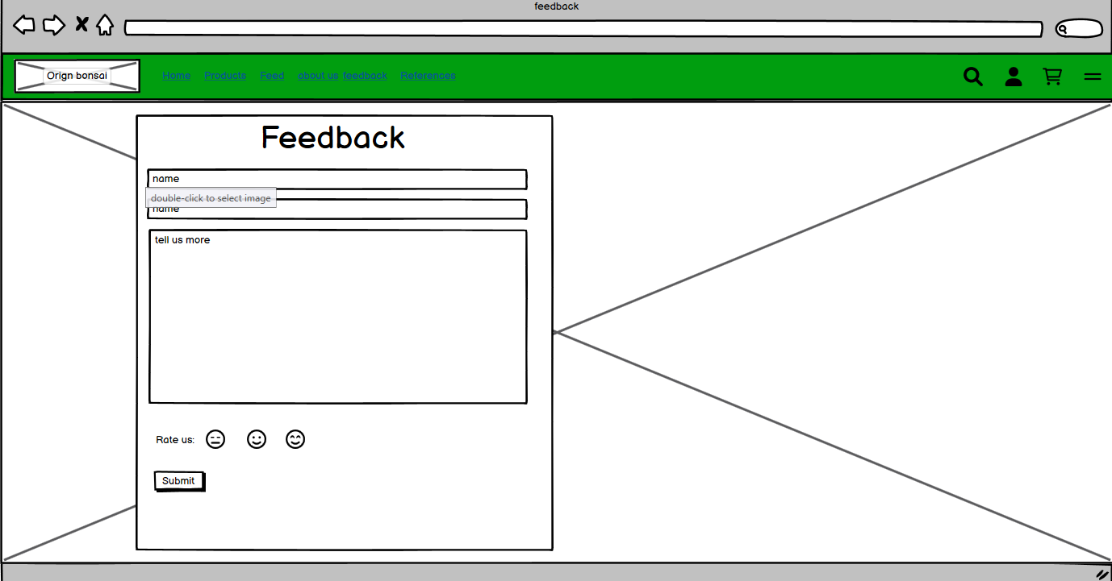

Figure 19: Feedback page wireframe

# TESTING

## JavaScript Testing

### Testing Form validation for feed-back Page

Table 1: Test1: Form Validation

|  |  |
| --- | --- |
| Test No: | 1 |
| Objective: | To Test if form is accepted only when all fields are filled |
| Action: | * Leave one field in feedback form empty * Check if error alert is shown |
| Expected Result: | When form is not filled completely an error alert is shown |
| Actual Result: | Error alert was shown when the form was not filled successfully |
| Conclusion: | The test is successful |

Let’s leave a field empty

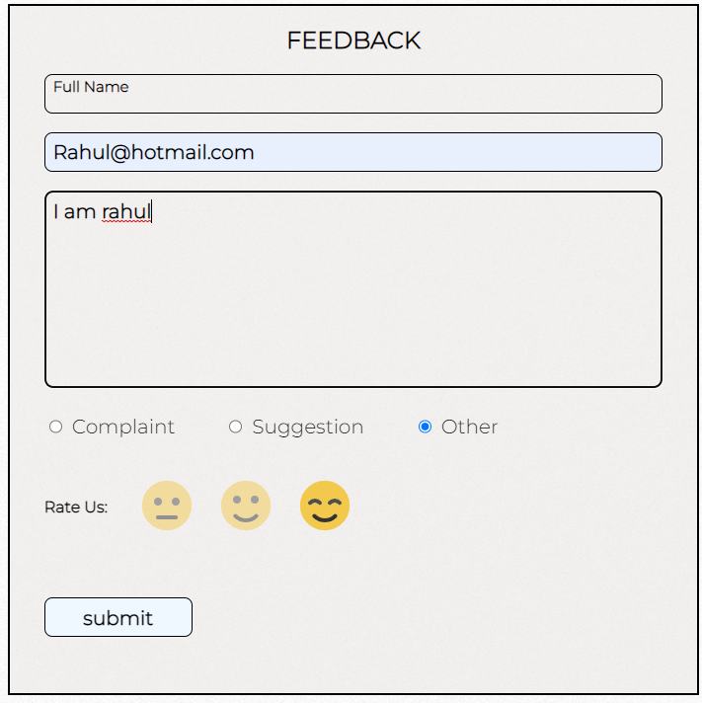

Figure 20: filling the form

As seen in the figure above, the name field has been left out empty. When we now try to submit this form, an error alert should be shown.

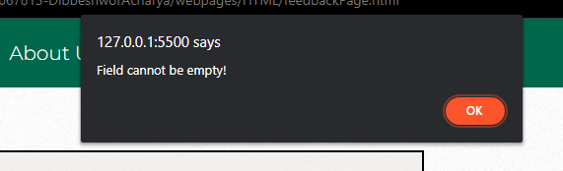

Figure 21: Error message for incomplete form

So, when we do not completely fill the form an error message is displayed.

### Testing “Rate Us:” emoji rating system

The emoji Rating System works by changing the opacity value of the selected emoji to 1 and the rest to 0.5. JavaScript is used to alter the CSS property of the images.

Table 2: Test 2: emoji rating

|  |  |
| --- | --- |
| Test No: | 2 |
| Objective: | To check if the emoji selector works |
| Action: | * Select lowest rating * Select middle rating |
| Expected Result: | When a selection is made, other emojis go back to being un-selected. |
| Actual Result: | When a selection was made, other emojis go back to being un-selected |
| Conclusion: | The test is successful |

We can see in the figure below when the lowest rating is selected, the other ratings become opaque automatically.

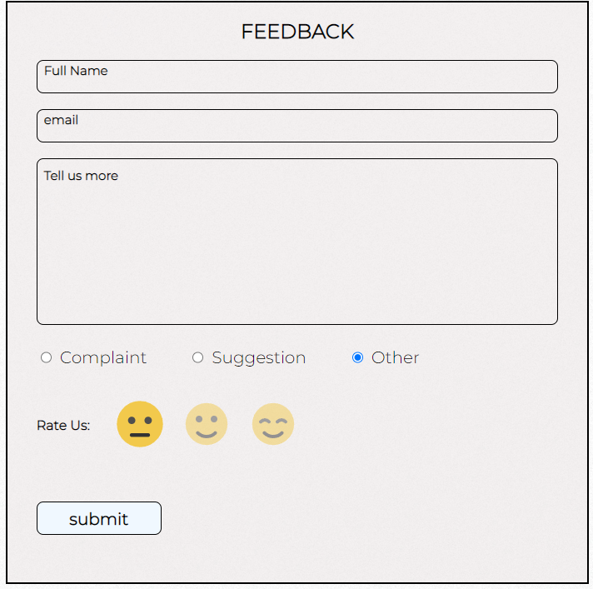

Figure 22: lowest rating

Accordingly, when we select the middle rating, the lowest rating gets opaque.

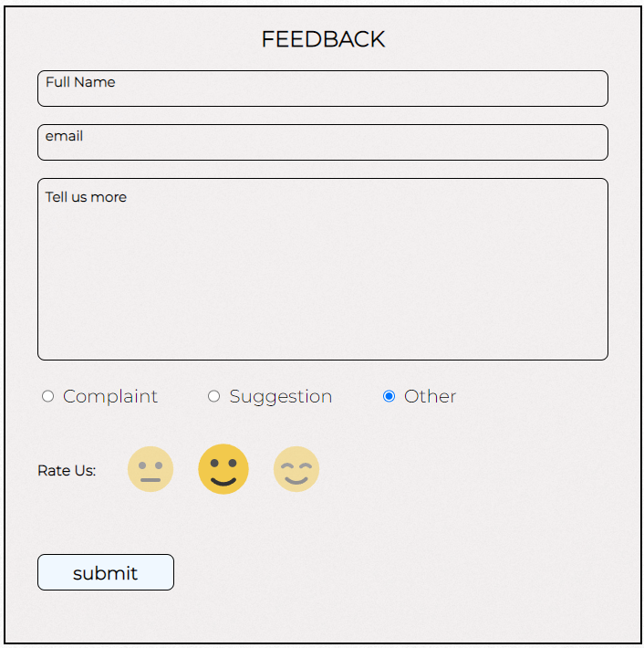

Figure 23: Middle rating

### Testing slider in feed page

The feed page contains a slider made using JavaScript. Along with images it scrolls text too.

Table 3: Test 3: Slider in Feed page

|  |  |
| --- | --- |
| Test No: | 3 |
| Objective: | To check if the feed slider works |
| Action: | * Click the next post arrow * Click the previous post arrow |
| Expected Result: | When next post arrow is selected, it scrolls to the next page and vice-versa |
| Actual Result: | The posts changed from next to previous |
| Conclusion: | The test is successful |

As seen in the images below, the next post and previous post arrows changes the posts accordingly.

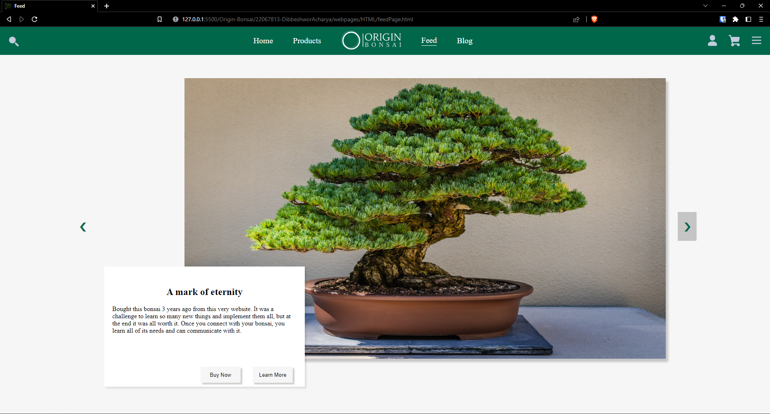

Figure 24: Before next button

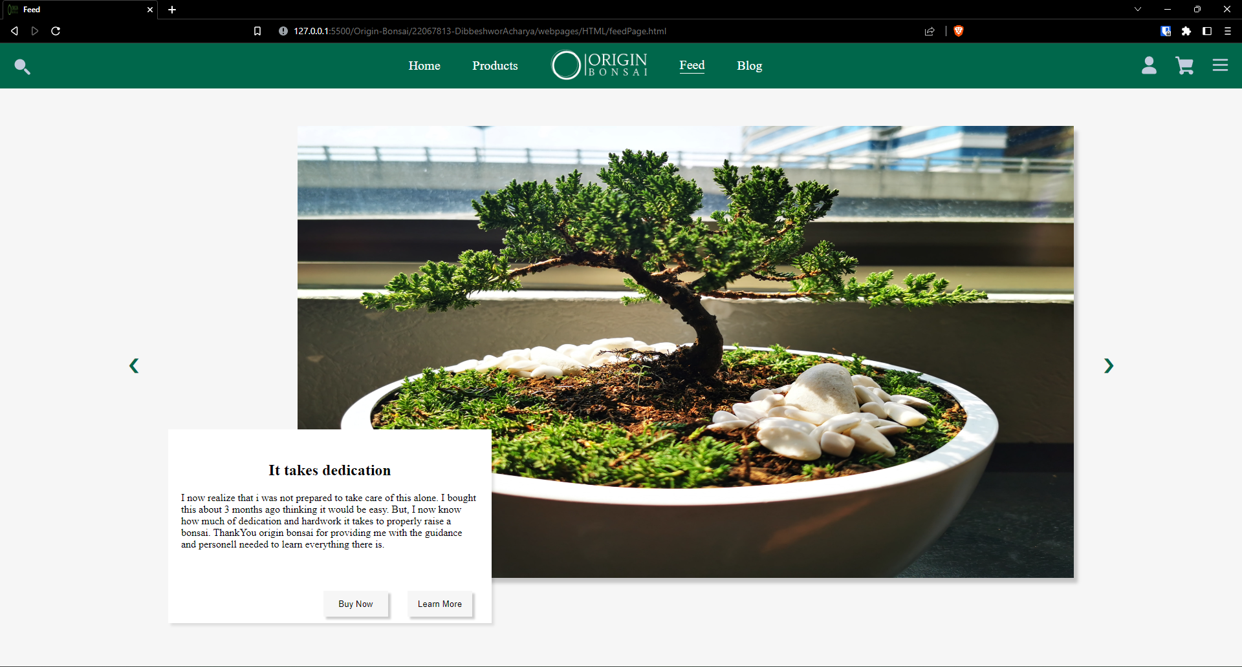

Figure 25: after next button

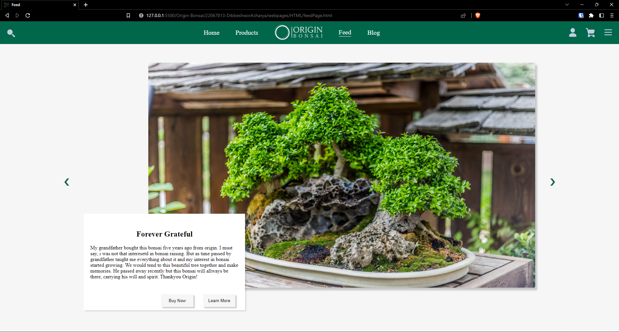

Figure 26: After previous button

## Navigation Hover Effect Testing

The header navigation elements have a hover effect added to them using CSS hover property. The element hovered over increase in size and is underlined.

Table 4: Test 4: nav hover testing

|  |  |
| --- | --- |
| Test No: | 4 |
| Objective: | To check if navigation hover effects work |
| Action: | * Hover mouse over navigation elements |
| Expected Result: | When mouse is hovered, the elements should increase in size and be underlined |
| Actual Result: | Hover effects were observed |
| Conclusion: | The test is successful |

As seen in the picture below, when mouse is hovered over the feedback option, it is bigger in size than other elements and is underlined.

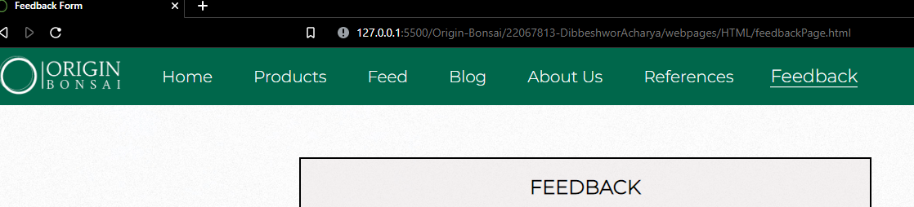

Figure 27: hover effect in nav bar

## Internal and External Link Testing

### Internal Link

To test the internal link, we will navigate from the home page to products page and from products page to home page.

Table 5: Internal Link Testing

|  |  |
| --- | --- |
| Test No: | 5 |
| Objective: | To check if internal link works |
| Action: | * Click the products page from home page * Open home page from products page |
| Expected Result: | Each page should open without showing any error |
| Actual Result: | Page opened without errors |
| Conclusion: | The test is successful |

When the product page was clicked, navigation was successful.

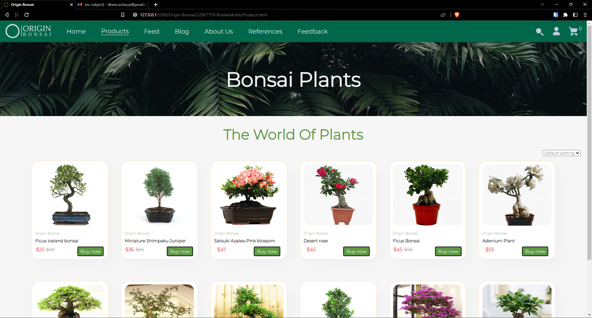

Figure 28: Home to Products

When the home page was clicked, navigation was successful.

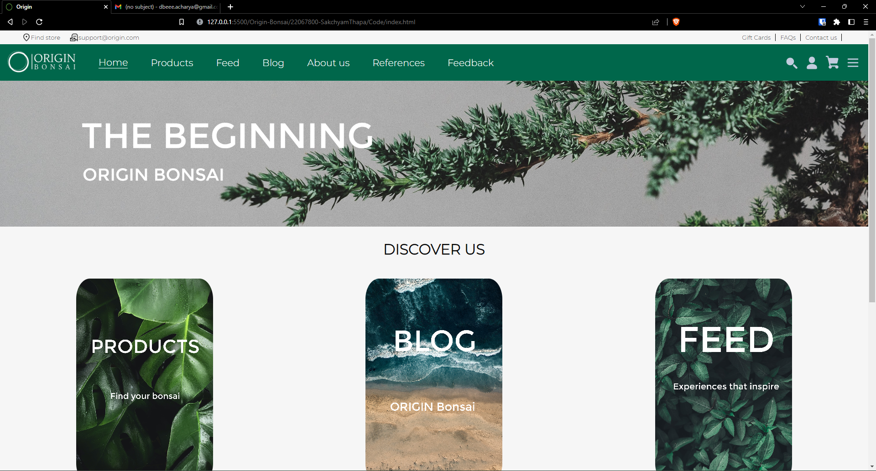

Figure 29: Products to Home

### External Link

The blog page contains an external link to a research paper. That website was not made by us and is not located within our folders. It is located on a completely different site. We can still access it by providing the correct url.

Table 6: Testing External Link

|  |  |
| --- | --- |
| Test No: | 5 |
| Objective: | To check if external link works |
| Action: | * Click on the 2017 study link referenced in the blog |
| Expected Result: | Successfully open the research website |
| Actual Result: | Research website was opened |
| Conclusion: | The test is successful |

As seen in the picture below, the link is highlighted and underlined.

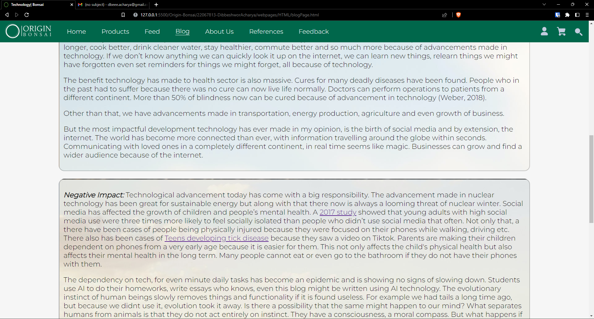

Figure 30: Before opening link

When the link is clicked, it opens this website:

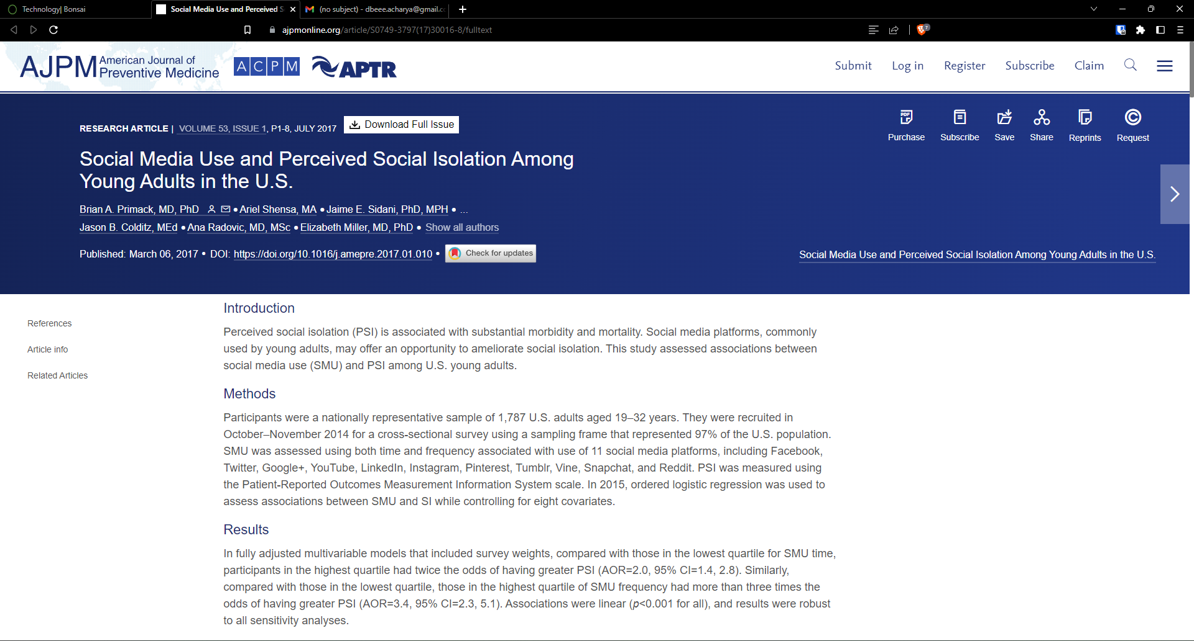

Figure 31:External Link

# CONCLUSION

In this coursework, HTML5, CSS3, and JavaScript were the primary focuses. The students are tasked with designing and developing an e-commerce website for a store that sells bonsai plants. The website must have at least 5 pages and meet guidelines for technology, design, and structure. The coursework is meant to demonstrate students' understanding of basic internet technologies, website design and development skills, and consideration of usability and accessibility. The accompanying documentation must include a cover page, a table of contents, an introduction, design and implementation details, testing results, and a reflection on the project. The goal of this coursework is to provide students with hands-on experience in creating a functional e-commerce website while considering various technical and design considerations.

As we worked on this project, we gained a lot of knowledge about HTML, CSS, and JS. Making an e-commerce website was a real-life prototype project that required us to create a working model of an actual e-commerce website. This coursework introduced us to various types of attributes and how and where to utilize them. It also broadened our understanding of JavaScript. It helped us comprehend how form validation works on a website. This project also helped us with our problem-solving abilities because we were having a lot of trouble with CSS and JS. While completing the assignment, the tutorial and workshop materials provided by the lecturer and tutor were quite useful.

The hardest part was to take all the individual ideas that each of our team members had and bring out something good of that. A band only sounds good if all of its members are in harmony, likewise, it took us quite some time to get in harmony and create a good looking website.

As seen below, the image on top is what we came up during the first week of doing this project. After a lot of figuring out and ironing out the kinks, the final product looks like the second image.

Overall, despite our little understanding of HTML, CSS, and JavaScript, the project was enjoyable and hard. The difficulties encouraged us to conduct a study and exert extra effort to finish the job as effectively as feasible.

# APPENDIX

This portion contains all the code for each of the webpages.

## HTML

### Home Page

<!DOCTYPE html>

<html>

<head>

<link rel="stylesheet" href="./src/style.css" />

<link rel="icon" href="../logo/png/logo-no-background.png" />

<!--Title logo-->

<title>Origin</title>

<script src="./src/script.js" defer></script>

<!--Title-->

</head>

<body>

<div class="menu">

<div class="button">

<p><a class="link" href="./potfolio.html">About us</p></a>

<p>References</p>

<p class="wallet">wallet points</p>

<p><a class="link" href="../../22067813-DibbeshworAcharya/webpages/HTML/feedbackPage.html"> feed-back</p></a>

</div>

</div>

<!--top f the header using z-index-->

<header>

<div class="whitetop">

<div class="arrangeleft">

<div>

<img src="../icons/location_on_FILL0_wght400_GRAD0_opsz48.png" />

<p>Find store</p>

</div>

<div>

<img src="../icons/local_post_office_FILL0_wght400_GRAD0_opsz48.png" />

<p>support@origin.com</p>

</div>

</div>

<div class="arrangeright">

<p>Gift Cards</p>

<p>FAQs</p>

<p>Contact us</p>

</div>

</div>

<!--white header-->

<div class="top">

<ul>

<a href="#"> <img src="../icons/logo-white-removebg.png" /></a>

<li class="active-page"><a class="home" href="#"> Home</a></li>

<li><a class="home" href="../../22067759-RoshaniKarki/Product.html">Products</a> </li>

<li><a class="home" href="../../22067813-DibbeshworAcharya/webpages/HTML/feedPage.html"> Feed</a></li>

<li><a class="home" href="../../22067759-RoshaniKarki/blog.html">Blog</li></a>

<li><a class="home" href="./potfolio.html">About us</li></a>

<li><a class="home" href="../../22067813-DibbeshworAcharya/webpages/HTML/referencePage.html">References</li></a>

<li><a class="home" href="../../22067813-DibbeshworAcharya/webpages/HTML/feedbackPage.html">Feedback</li></a>

</ul>

<div class="icons">

<img class="insideicon" src="../../22067813-DibbeshworAcharya/icons/Header-Icons/search.svg">

<img

class="insideicon"

src="../../22067813-DibbeshworAcharya/icons/Header-Icons/user.svg"

/>

<a href="../../22067813-DibbeshworAcharya/webpages/HTML/cartPage.html"><img

class="insideicon"

src="../../22067813-DibbeshworAcharya/icons/Header-Icons/shopping-cart.svg"

/></a> <img

class="insideicon menubutton"

src="../../22067813-DibbeshworAcharya/icons/Header-Icons/menu.svg"

/>

</div>

</div>

<!--for green header-->

</header>

<div class="back">

<!--new class for background body-->

<!--header-->

<div style="width: 100%;">

<img class="mainimg" src="../images/banner.jpg" />

</div>

<!--main image-->

</div>

<h1 class="title">DISCOVER US</h1>

<!--Flip bonsai-->

<div class="mainhover">

<div class="flip-box">

<div class="flip-box-inner">

<div class="flip-box-front">

<img src="../images/flipImage2.jpg" alt="" />

</div>

<div class="flip-box-back">

<a href="../../22067759-RoshaniKarki/Product.html"><h2><br>Find your bonsai</h2>

<p>

Our product page contains a collection of bonsai, carefully selected by our experts.

Though small in quantity, each breed of bonsai has proven to be rigorous and has been celebrated

by bonsai experts around the world for decades. We also provide you with the option to hire an expert

if you need any help in getting accustomed with your new found passion.

</p>

<p>

Browse our selection now and find your perfect match

</p>

</a>

</div>

</div>

</div>

<div class="flip-box">

<div class="flip-box-inner">

<div class="flip-box-front">

<img src="../images/flipImage3.jpg" alt="Paris" />

</div>

<div class="flip-box-back">

<a href="../../22067813-DibbeshworAcharya/webpages/HTML/blogPage.html"><h2><br>Technology, bonsai and more</h2>

<p>

Read interesting notes written by our team. Our latest blog is regarding technology and how it affects Origin Bonsai.

We also have a blog about bonsai plants and a blog that takes you through the process of how we developed this website. The blogs

are written and maintained by the origin team.

</p>

<p>

Click to read our latest blog about technology and bonsai

</p>

</a>

</div>

</div>

</div>

<div class="flip-box">

<div class="flip-box-inner">

<div class="flip-box-front">

<img src="../images/flipimage4.png" alt="Paris" />

</div>

<div class="flip-box-back">

<a href="../../22067813-DibbeshworAcharya/webpages/HTML/feedPage.html"><h2><br>Experiences that aspire to inspire</h2>

<p>

The feed page is a unique experience developed by the Origin team as a platform for our

users and clients to share stories about their bonsai and help inspire others to dive into this passion.

All the stories are vetted and verified by our team before they are published. Please contact us through the

feedback page to share your story.

</p>

<p>

Click here to read stories that might be the push you need!

</p>

</a>

</div>

</div>

</div>

</div>

<!--hoverflip end-->

<!--costumer bar-->

<div class="bottombar">

<div class="barmenu">

<div class="insidebar">

<img src="../icons/local_shipping_FILL0_wght400_GRAD0_opsz48.png" />

<p>Free delivery</p>

</div>

<div class="insidebar">

<img src="../icons/payments_FILL0_wght400_GRAD0_opsz48.png" />

<p>Secure payments</p>

</div>

<div class="insidebar">

<img src="../icons/support_agent_FILL0_wght400_GRAD0_opsz48.png" />

<p>Top-notch support</p>

</div>

<div class="insidebar">

<img src="../icons/star_rate_FILL0_wght400_GRAD0_opsz48.png" />

<p>Ratings</p>

</div>

</div>

</div>

<!--ending of bar-->

<!--footer-->

<footer>

<div class="footleft">

<img class="footlogo" src="../images/logo-no-background.png"/>

<p>support.origin@gmail.com</p>

<p>+977-9867345871</p>

<p>

Privacy Policy

</p>

</div>

<div class="footmiddle">

<div class="middlefoot">

<p><a href="../../22067759-RoshaniKarki/Product.html"> Bonsai plants</a></p>

<p><a href="#"> Track delivery</a></p>

<p><a href="../../22067759-RoshaniKarki/bonsaigallery.html">Bonsai Gallery</a></p>

<p><a href="#">Contacts</a></p>

<p><a href="#">Support</a></p>

</div>

</div>

<div class="footright">

<input placeholder="Email address">

<button>Subscribe</button>

<div class="rightfoot">

<img src="../icons/facebook.svg"/>

<img src="../icons/instagram.svg"/>

<img src="../icons/twitter.svg"/>

<img src="../icons/mail.svg"/>

<img src="../icons/youtube.svg"/>

</div>

</div>

</footer>

<!--main footer-->

<p class="copy">Origin &copy; 2023</p>

</body>

</html>

### Products Page

<!--Our HTML code starts here-->

<!DOCTYPE html>

<html lang="en">

<head>

<meta charset="UTF-8">

<meta http-equiv="X-UA-Compatible" content="IE=edge">

<meta name="viewport" content="width=device-width, initial-scale=1.0">

<title>Origin Bonsai</title>

<link rel="stylesheet" href="./css/style.css">

<link rel="stylesheet" href="../22067813-DibbeshworAcharya/webpages/CSS/header-style.css">

<link rel="icon" href="../22067800-SakchyamThapa/logo/png/logo-no-background.png">

</head>

<body>

<!--our header starts here-->

<header>

<!--This div wraps the middle part of the header-->

<div class="header-content middle">

<ul>

<!--The middle-links class is given so that transform can be applied to only the specified links and not the image-->

<li>

<a href="../22067800-SakchyamThapa/Code/index.html"><img src="./LOGO/png/logo-white-removebg.png" alt="main logo" style="width: 150px; overflow: hidden;" id="logo-header"></a>

</li>

<!--Inline css was used to override the external css for width-->

<li class="middle-links">

<a href="../22067800-SakchyamThapa/Code/index.html" ">Home</a>

</li>

<li class="middle-links header-active">

<a href="#">Products</a>

</li>

<li class="middle-links ">

<a href="../22067813-DibbeshworAcharya/webpages/HTML/feedPage.html">

Feed</a>

</li>

<li class="middle-links">

<a href="./blog.html">Blog</a>

</li>

<li class="middle-links">

<a href="../22067800-SakchyamThapa/Code/potfolio.html">About Us</a>

</li>

<li class="middle-links">

<a href="../22067813-DibbeshworAcharya/webpages/HTML/referencePage.html">References</a>

</li>

<li class="middle-links">

<a href="../22067813-DibbeshworAcharya/webpages/HTML/feedbackPage.html">Feedback</a>

</li>

</ul>

</div>

<!--This div wraps the right part of the header-->

<div class="header-content right">

<img src="./header-icons/search.svg" alt="search icon">

<a href=""><img src="./header-icons/user.svg" alt="user icon"></a>

<a href="../22067813-DibbeshworAcharya/webpages/HTML/cartPage.html"><img src="./header-icons/shopping-cart.svg" alt="shopping cart icon"><inline id="numberCart">0</inline></a>

</div>

</header>

<!--our product page starts here-->

<section id="product">

<h1>Bonsai Plants</h1>

</section>

<section id="product1" class="section-p1">

<h2>The World Of Plants</h2>

<!--tag for price sorting starts here-->

<div class="defult">

<select>

<option>Default sorting</option>

<option>Sort by price</option>

<option>Sort by sale</option>

</select>

</div>

<!--grid view to display products line by-->

<div class="grid-view">

<div

class="pro-container">

<!--using a tag to link ficusIceland.html page for description-->

<a href="./products-page/ficusIceland.html">

<div class="pro">

<img src="images/1.Ficus iceland bonsai plant.jpg" alt="">

<div class="des">

<span>Origin Bonsai</span>

<h5>Ficus iceland bonsai</h5>

</div>

<!----price counter to detarmine the price-->

<div class="priceCounter">

<div class="price">

<h4>$25</h4>

<p>

<s>$50</s>

</p>

</div>

</a>

<div>

<button class="normal" onclick="addCart()">Buy now</button>

</div>

</div>

</div>

</div>

<!--making a container for a single product-->

<div class="pro-container">

<div

class="pro">

<!--using a tag to link miniature.html page for description-->

<a href="./products-page/miniature.html">

<img src="images/2.Miniature Shimpaku Juniper.webp" alt="">

<div class="des">

<span>Origin Bonsai</span>

<h5>Miniature Shimpaku Juniper</h5>

</div>

<!----price counter to detarmine the price-->

<div class="priceCounter">

<div class="price">

<h4>$36</h4>

<p>

<s>$45</s>

</p>

</div>

</a>

<div>

<button class="normal" onclick="addCart()">Buy now</button>

</div>

</div>

</div>

</div>

<!--making a container for a single product-->

<div class="pro-container">

<div

class="pro">

<!--using a tag to link satsuki.html page for description-->

<a href="./products-page/satsuki.html">

<img src="images/3.Satsuki azalea-Pink blossom.webp " alt="">

<div class="des">

<span>Origin Bonsai</span>

<h5>Satsuki Azalea-Pink blossom</h5>

</div>

<!----price counter to detarmine the price-->

<div class="priceCounter">

<div class="price">

<h4>$47</h4>

</div>

</a>

<div>

<button class="normal" onclick="addCart()">

Buy now</button>

</div>

</div>

</div>

</div>

<!--making a container for a single product-->

<div class="pro-container">

<div

class="pro">

<!--using a tag to link desert.html page for description-->

<a href="./products-page/desert.html">

<img src="images/4.Desert rose.jpg" alt="">

<div class="des">

<span>Origin Bonsai</span>

<h5>Desert rose</h5>

</div>

<!----price counter to detarmine the price-->

<div class="priceCounter">

<div class="price">

<h4>$45</h4>

</div>

</a>

<div>

<button class="normal" onclick="addCart()">Buy now</button>

</div>

</div>

</div>

</div>

<!--making a container for a single product-->

<div class="pro-container">

<div

class="pro">

<!--using a tag to link ficus.html page for description-->

<a href="./products-page/ficusbonsai.html">

<img src="IMAGES/5.ficus-bonsai-plant.jpg" alt="">

<div class="des">

<span>Origin Bonsai</span>

<h5>Ficus Bonsai</h5>

</div>

<!----price counter to detarmine the price-->

<div class="priceCounter">

<div class="price">

<h4>$45</h4>

<p>

<s>$50</s>

</p>

</div>

</a>

<div>

<button class="normal" onclick="addCart()">Buy now</button>

</div>

</div>

</div>

</div>

<!--making a container for a single product-->

<div class="pro-container">

<div

class="pro">

<!--using a tag to link adenium.html page for description-->

<a href="./products-page/adenium.html">

<img src="IMAGES/6.adenium-plant-white.jpg" alt="">

<div class="des">

<span>Origin Bonsai</span>

<h5>Adenium Plant</h5>

</div>

<!----price counter to detarmine the price-->

<div class="priceCounter">

<div class="price">

<h4>$55</h4>

</div>

</a>

<div>

<button class="normal" onclick="addCart()">Buy now</button>

</div>

</div>

</div>

</div>

<!--making a container for a single product-->

<div class="pro-container">

<div

class="pro">

<!--using a tag to link ulmus.html page for description-->

<a href="./products-page/ulmus.html">

<img src="IMAGES/7.ulmus_parvifolia.jpg" alt="">

<div class="des">

<span>Origin Bonsai</span>

<h5>Ulmus Parvifolia</h5>

</div>

<div

class="priceCounter">

<!----price counter to detarmine the price-->

<div class="price">

<h4>$47</h4>

<p>

<s>$50</s>

</p>

</div>

</a>

<div>

<button class="normal" onclick="addCart()">Buy now</button>

</div>

</div>

</div>

</div>

<!--making a container for a single product-->

<div class="pro-container">

<div

class="pro">

<!--using a tag to link serissa.html page for description-->

<a href="./products-page/serissa.html">

<img src="IMAGES/8.serissa_foetida.jpg" alt="">

<div class="des">

<span>Origin Bonsai</span>

<h5>serissa Foetida</h5>

</div>

<!----price counter to detarmine the price-->

<div class="priceCounter">

<div class="price">

<h4>$45</h4>

</div>

</a>

<div>

<button class="normal" onclick="addCart()">Buy now</button>

</div>

</div>

</div>

</div>

<!--making a container for a single product-->

<div class="pro-container">

<div

class="pro">

<!--using a tag to link abana.html page for description-->

<a href="./products-page/abana.html">

<img src="IMAGES/9.Abana homes ulmus.jpg" alt="">

<div class="des">

<span>Origin Bonsai</span>

<h5>Abana homes ulmus</h5>

</div>

<!----price counter to detarmine the price-->

<div class="priceCounter">

<div class="price">

<h4>$40</h4>

<p>

<s>$50</s>

</p>

</div>

</a>

<div>

<button class="normal" onclick="addCart()">Buy now</button>

</div>

</div>

</div>

</div>

<!--making a container for a single product-->

<div class="pro-container">

<div

class="pro">

<!--using a tag to link boxwood.html page for description-->

<a href="./products-page/boxwood.html">

<img src="IMAGES/10.Boxwood.jpg" alt="">

<div class="des">

<span>Origin Bonsai</span>

<h5>Boxwood Bonsai</h5>

</div>

<!----price counter to detarmine the price-->

<div class="priceCounter">

<div class="price">

<h4>$40</h4>

<p>

<s>$50</s>

</p>

</div>

</a>

<div>

<button class="normal" onclick="addCart()">Buy now</button>

</div>

</div>

</div>

</div>

<!--making a container for a single product-->

<div class="pro-container">

<div

class="pro">

<!--using a tag to link bougainvillea.html page for description-->

<a href="./products-page/Bougainvillea.html">

<img src="IMAGES/11.Bougainvillea-Bonsai.webp" alt="">

<div class="des">

<span>Origin Bonsai</span>

<h5>Bougainvillea Bonsai</h5>

</div>

<!----price counter to detarmine the price-->

<div class="priceCounter">

<div class="price">

<h4>$50</h4>

</div>

</a>

<div>

<button class="normal" onclick="addCart()">Buy now</button>

</div>

</div>

</div>

</div>

<!--making a container for a single product-->

<div class="pro-container">

<div

class="pro">

<!--using a tag to link microcaroa.html page for description-->

<a href="./products-page/microcaroa.html">

<img src="IMAGES/13.Ficus microcarpa.jpg" alt="">

<div class="des">

<span>Origin Bonsai</span>

<h5>Microcarpa Bonsai</h5>

</div>

<!----price counter to detarmine the price-->

<div class="priceCounter">

<div class="price">

<h4>$50</h4>

</div>

</a>

<div>

<button class="normal" onclick="addCart()">Buy now</button>

</div>

</div>

</div>

</div>

</div>

<!--grid ends here-->

</section>

<!--Section tag ends here-->

<script>

var cartNumber = document.getElementById("numberCart");

var num = 0

function addCart() {

num = num + 1;

cartNumber.innerHTML = num;

}

</script>

</body>

</html>

### Feed Page

<!DOCTYPE html>

<html>

<head>

<meta name="author" content="Dibbeshwor Acharya">

<meta name="viewport" content="width=device-width, initial-scale=1.0">

<meta name="keywords" content="feed, bonsai, updates, community">

<link rel="stylesheet" href="../CSS/feed-style.css">

<link rel="stylesheet" href="../css/header-style.css">

<link rel="icon" href="../../../22067800-SakchyamThapa/logo/png/logo-no-background.png" />

<title>Feed</title>

<!--This style tag will have the universal selector and the body tag-->

<style>

* {

box-sizing: border-box; /*Makes sure that margin and padding is also included in width and height values*/

}

body {

margin: 0;

background-color: #f6f6f6;

}

</style>

</head>

<body>

<!--The header tag wraps the topmost part i.e. the header of the page-->

<div class="main-content-page">

<header>

<!--This div wraps the middle part of the header-->

<div class="header-content middle">

<ul>

<!--The middle-links class is given so that transform can be applied to only the specified links and not the image-->

<li><a href="../../../22067800-SakchyamThapa/Code/index.html"><img src="../../logo/png/logo-white-removebg.png" alt="main logo" style="width: 150px; overflow: hidden;" id="logo-header"></a></li> <!--Inline css was used to override the external css for width-->

<li class="middle-links"><a href="../../../22067800-SakchyamThapa/Code/index.html"">Home</a></li>

<li class="middle-links"><a href="../../../22067759-RoshaniKarki/Product.html">Products</a></li>

<li class="middle-links header-active"><a href="./feedPage.html"> Feed</a></li>

<li class="middle-links" ><a href="../../../22067759-RoshaniKarki/blog.html">Blog</a></li>

<li class="middle-links"><a href="../../../22067800-SakchyamThapa/Code/potfolio.html">About Us</a></li>

<li class="middle-links"><a href="./referencePage.html">References</a></li>

<li class="middle-links"><a href="./feedbackPage.html">Feedback</a></li>

</ul>

</div>

<!--This div wraps the right part of the header-->

<div class="header-content right">

<img src="../../icons/header-icons/search.svg" alt="search icon">

<a href=""><img src="../../icons/header-icons/user.svg" alt="user icon"></a>

<a href="./cartPage.html"><img src="../../icons/header-icons/shopping-cart.svg" alt="shopping cart icon"></a>

</div>

</header>

<!--This section tag is for the main section of the webpage that contains all the main contents-->

<section class="main-container">

<!-- button to view previous slide -->

<a class="back" onclick="prevSlide()" style="margin-right: 10px;">&#10094</a>

<!-- main post container -->

<div class="post-container active" id="post1" >

<!-- post text along with buttons -->

<div class="post-content">

<h2 style="text-align: center;">A mark of eternity</h2>

<p>

Bought this bonsai 3 years ago from this very website. It was a challenge to learn so many new things

and implement them all, but at the end it was all worth it. Once you connect with your bonsai, you learn

all of its needs and can communicate with it.

</p>

<div class="post-interaction">

<a href="../../../22067759-RoshaniKarki/Product.html"><button>Buy Now</button></a>

<button>Learn More</button>

</div>

</div>

<!-- image for post -->

<div class="post-photo">

<img src="../../images/bonsai-1.jpg " alt="bonsia photo" style="width: 1200px; height: 700px;">

</div>

</div>

<div class="post-container" id="post2">

<div class="post-content">

<h2 style="text-align: center;">It takes dedication</h2>

<p>

I now realize that i was not prepared to take care of this alone. I bought this about 3 months ago thinking

it would be easy. But, I now know how much of dedication and hardwork it takes to properly raise a bonsai. ThankYou

origin bonsai for providing me with the guidance and personell needed to learn everything there is.

</p>

<div class="post-interaction">

<a href="../../../22067759-RoshaniKarki/Product.html"><button>Buy Now</button></a>

<button>Learn More</button>

</div>

</div>

<div class="post-photo">

<img src="../../images/feed-page2.jpg" alt="bonsia photo" style="width: 1200px; height: 700px;">

</div>

</div>

<div class="post-container" id="post3">

<div class="post-content">

<h2 style="text-align: center;">Its an art</h2>

<p>

Many people dive right in and buy a new bonsai without realizing the effort they need to put. Its like

raising a child. You must constantly care and tend to the bonsai, otherwise your efforts will all go into

vain. I recommend hiring an expert from origin while buying a bonsai to make sure that you are up for the task.

</p>

<div class="post-interaction">

<a href="../../../22067759-RoshaniKarki/Product.html"><button>Buy Now</button></a>

<button>Learn More</button>

</div>

</div>

<div class="post-photo">

<img src="../../images/bonsai-test.jpg" alt="bonsia photo" style="width: 1200px; height: 700px;">

</div>

</div>

<div class="post-container" id="post4">

<div class="post-content">

<h2 style="text-align: center;">Forever Grateful</h2>

<p>

My grandfather bought this bonsai five years ago from origin. I must say, i was not that

interesetd in bonsai raising. But as time passed by grandfather taught me everything about it and

my interest in bonsai started growing. We would tend to this beautiful tree together and make memories.

He passed away recently but this bonsai will allways be there, carrying his will and spirit. Thankyou Origin!

</p>

<div class="post-interaction">

<a href="../../../22067759-RoshaniKarki/Product.html"><button>Buy Now</button></a>

<button>Learn More</button>

</div>

</div>

<div class="post-photo">

<img src="../../images/feed-page3.jpg" alt="bonsia photo" style="width: 1200px; height: 700px;">

</div>

</div>

<!-- button to show previous post -->

<a class="next" onclick="nextSlide()" style="margin-left:10px;">&#10095</a>

</section>

</div>

<!-- JavaScript to change the slides -->

<script>

var content = document.querySelectorAll(".post-content"); //selects all elements with the class "post-content"

var x = 0; //x shows the current post number

var y = 4; //y shows the total number of posts

//nextSlide function scrolls to the next post

function nextSlide() {

document.getElementById("post" + (x+1)).classList.remove("active"); //selects the current post and removes the active class which contains the display block

x = (x + y + 1) % y; //this changes the value of x to the next post and reverts it to 1 if x exceeds the value of number of posts

document.getElementById("post" + (x+1)).classList.add("active") //selects the post next to the current oone and adds the current class

}

//prevSlide function scrolls back to the previous slide

function prevSlide() {

document.getElementById("post" + (x+1)).classList.remove("active"); //selects the current post and removes the active class

x = (x + y - 1) % y //changes the value of x to the post previous to the current one and reverts it to 1 if x is less than 0

document.getElementById("post" + (x+1)).classList.add("active"); //selects the previous post and adds the active class

}

</script>

</body>

</html>

### Blog Page

<!--Our HTML code starts here-->

<!DOCTYPE html>

<html lang="en">

<head>

<meta charset="UTF-8">

<meta http-equiv="X-UA-Compatible" content="IE=edge">

<meta name="viewport" content="width=device-width, initial-scale=1.0">

<title>Origin Bonsai</title>

<link rel="stylesheet" href="./CSS/style.css">

<link rel="stylesheet" href="./css/header-style.css">

<link rel="icon" href="../22067800-SakchyamThapa/logo/png/logo-no-background.png"/>

</head>

<body>

<header>

<!--This div wraps the middle part of the header-->

<div class="header-content middle">

<ul>

<!--The middle-links class is given so that transform can be applied to only the specified links and not the image-->

<li>

<a href="../22067800-SakchyamThapa/Code/index.html"><img src="./LOGO/png/logo-white-removebg.png" alt="main logo" style="width: 150px; overflow: hidden;" id="logo-header"></a>

</li>

<!--Inline css was used to override the external css for width-->

<li class="middle-links">

<a href="../22067800-SakchyamThapa/Code/index.html" ">Home</a>

</li>

<li class="middle-links ">

<a href="./Product.html">Products</a>

</li>

<li class="middle-links ">

<a href="../22067813-DibbeshworAcharya/webpages/HTML/feedPage.html">

Feed</a>

</li>

<li class="middle-links header-active">

<a href="./blog.html">Blog</a>

</li>

<li class="middle-links">

<a href="../22067800-SakchyamThapa/Code/potfolio.html">About Us</a>

</li>

<li class="middle-links">

<a href="../22067813-DibbeshworAcharya/webpages/HTML/referencePage.html">References</a>

</li>

<li class="middle-links">

<a href="../22067813-DibbeshworAcharya/webpages/HTML/feedbackPage.html">Feedback</a>

</li>

</ul>

</div>

<!--This div wraps the right part of the header-->

<div class="header-content right">

<img src="./header-icons/search.svg" alt="search icon">

<a href=""><img src="./header-icons/user.svg" alt="user icon"></a>

<a href="../22067813-DibbeshworAcharya/webpages/HTML/cartPage.html"><img src="./header-icons/shopping-cart.svg" alt="shopping cart icon"></a>

</div>

</header>

<!--our blog page starts here-->

<section

id="Blog">

<!--heading------>

<div class="blogs">

<h1>Blogs</h1>

<h6>Recent Posts</h6>

</div>

<!--blog items-->

<div class="blog-container">

<div

class="blog-box">

<!--imageee-->

<div class="blog-img">

<a href="../22067813-DibbeshworAcharya/webpages/HTML/blogPage.html">

<img src="../22067813-DibbeshworAcharya/images/Technology.png" alt="blog">

</a>

</div>

<div

class="blog-text">

<!--blog content-------->

<a href="../22067813-DibbeshworAcharya/webpages/HTML/blogPage.html" class="blog-title">Technology and Bonsai</a>

</div>

</div>

</div>

<!--table tag from now-->

<table>

<tr>

<th>

<div class="blog-container1 blog-container">

<div

class="blog-box1">

<!--image-->

<div class="blog-img1">

<a href="./aboutbonsai.html"><img src="./images for blog/Blogpage2.avif" alt="blog"></a>

</div>

<div

class="blog-text1">

<!--blog content-------->

<a href="#" class="blog-title1">What are Bonsai Plants?</a>

<p>Introduction to Bonsai and Its History

We must study more about the significance and background of bonsai if we want to comprehend what it is. Over 2000 years ago, the Chinese began to make tiny landscapes. The more magically potent the reproduction was expected to be, the smaller it was in comparison to the original. Its magical attributes could be accessed by a pupil who focuses on them. The Japanese imitated the art form during the Kamakura period (700 years ago), and from that point on, a particular Japanese style developed. The Japanese started cultivating individual trees rather than entire landscapes. What we now refer to as bonsai trees are these trees.</p>

<a href="./aboutbonsai.html">Read more</a>

</div>

</div>

</div>

</th>

<th>

<div class="blog-container1 blog-container">

<div

class="blog-box1">

<!--imageee-->

<div class="blog-img1">

<img src="images for blog/designed.jpg" alt="blog">

</div>

<div

class="blog-text1">

<!--blog content-------->

<a href="#" class="blog-title1">How we designed our website?</a>

<p>Our website's design prioritizes easy navigation and a clean, modern aesthetic with the user in mind. Our objective was to create a visually appealing internet platform that effectively advertises our products and services.

</p>

<a href="designed.html">Read more</a>

</div>

</div>

</div>

</th>

</tr>

</table>

</div>

<div class="blog-container">

<a href="bonsaigallery.html">

<div

class="blog-box">

<!--imageee-->

<div class="blog-img">

<img src="images for blog/blogpage3.jpg" alt="blog">

</div>

<div

class="blog-text">

<!--blog content-------->

<h2>Bonsai Gallery</h2>

</div>

</a>

</div>

</section>

<script src="script.js"></script>

</body>

</html>

### About Us

<!DOCTYPE html>

<html>

<head>

<link rel="stylesheet" href="./potfolio/potfolio.css" />

<link rel="icon" href="../logo/png/logo-no-background.png" />

<!--Title logo-->

<title>Origin</title>

<script src="./potfolio/potfolio.js" defer></script>

<!--Title-->

</head>

<body>

<!--menu start-->

<div class="menu">

<div class="button">

<p><a class="link" href="./potfolio.html"> About us</a></p>

<p>References</p>

<p class="wallet">wallet points</p>

<p><a class="link" href="../../22067813-DibbeshworAcharya/webpages/HTML/feedbackPage.html"> feed-back</p></a>

</div>

</div>

<!--menu end-->

<div class="menu">

<div class="button">

<p><a class="link" href="./potfolio.html">About us</p></a>

<p>References</p>

<p class="wallet">wallet points</p>

<p><a class="link" href="../../22067813-DibbeshworAcharya/webpages/HTML/feedbackPage.html"> feed-back</p></a>

</div>

</div>

<!--top f the header using z-index-->

<header>

<!--white header-->

<div class="top">

<ul>

<a href="#"> <img src="../icons/logo-white-removebg.png" /></a>

<li ><a class="home" href="./index.html"> Home</a></li>

<li><a class="home" href="../../22067759-RoshaniKarki/Product.html">Products</a> </li>

<li><a class="home" href="../../22067813-DibbeshworAcharya/webpages/HTML/feedPage.html"> Feed</a></li>

<li><a class="home" href="../../22067759-RoshaniKarki/blog.html">Blog</li></a>

<li><a class="home active-page" href="./potfolio.html">About us</li></a>

<li><a class="home" href="../../22067813-DibbeshworAcharya/webpages/HTML/referencePage.html">References</li></a>

<li><a class="home" href="../../22067813-DibbeshworAcharya/webpages/HTML/feedbackPage.html">Feedback</li></a>

</ul>

<div class="icons">

<img class="insideicon" src="../../22067813-DibbeshworAcharya/icons/Header-Icons/search.svg">

<img

class="insideicon"

src="../../22067813-DibbeshworAcharya/icons/Header-Icons/user.svg"

/>

<a href="../../22067813-DibbeshworAcharya/webpages/HTML/cartPage.html"><img

class="insideicon"

src="../../22067813-DibbeshworAcharya/icons/Header-Icons/shopping-cart.svg"

/></a> <img

class="insideicon menubutton"

src="../../22067813-DibbeshworAcharya/icons/Header-Icons/menu.svg"

/>

</div>

</div>

<!--for green header-->

</header>

<!--main potfolio-->

<!---------------------------------------------------------- roshni karki's portfolio --------------------------------------------------------------------->

<div id="roshni">

<a href="./potfolio.html"><img src="../../22067759-RoshaniKarki/Header-Icons/cross.svg" alt="" class="close"></a>

<div class="portfolio">

<img src="../images/roshni karki.png" alt="">

<h1>I am roshani Karki</h1>

<ul style="margin-bottom: 40px;">

<li>Address: Biratnagar</li>

<li>Contact: Roshni@gmail.com</li>

<li>Instagram: <a href="https://www.instagram.com/roshni.jk/">Click Me!</a></li>

</ul>

</div>

<div class="portfolio-details">

<div>

<h1>Education</h1>

<ul>

<li>College: Islington College Nepal (2022-ongoing) </li>

<li>highschool: Biratnagar College (2022-2020) </li>

<li>school: Biratnagar School </li>

</ul>

</div>

<div>

<h1>Work Experience</h1>

<ul>

<li>Worked as a web developer intern (2022)</li>

<li>Online business (2020)</li>

<li>Nail artist (2019-2020)</li>

</ul>

</div>

<div>

<h1>Skills</h1>

<ul>

<li>Good at persuasion</li>

<li>Can speak English, Hindi, Nepali</li>

<li>Have completed professional nail art classes</li>

<li>FrontEnd web development</li>

</ul>

</div>

<div>

<h1>Hobbies</h1>

<ul>

<li>Watching Movies, Playing Soduku, Reading Books and spam posting</li>

</ul>

</div>

</div>

</div>

<!------------------------------------------------------------- yogals portfolio ---------------------------------------------------------------->

<div id="yogal">

<a href="./potfolio.html"><img src="../../22067759-RoshaniKarki/Header-Icons/cross.svg" alt="" class="close"></a>

<div class="portfolio">

<img src="../images/yogal.jpg" alt="">

<h1>I am Yogal Thapa Magar</h1>

<ul style="margin-bottom: 40px;">

<li>Address: Bhaktapur</li>

<li>Contact: Yogal@gmail.com</li>

<li>Instagram: <a href="https://www.instagram.com/sangam_thapa0.0/">Click Me!</a></li>

</ul>

</div>

<div class="portfolio-details">

<div>

<h1>Education</h1>

<ul>

<li>College: Islington College Nepal (2022-ongoing) </li>

<li>highschool: Itahari College </li>

<li>school: Itahari School</li>

</ul>

</div>

<div>

<h1>Work Experience</h1>

<ul>

<li>Retailor at Fantech Nepal store (2021)</li>

<li>Freelance Web Developer (2020-2021)</li>

</ul>

</div>

<div>

<h1>Skills</h1>

<ul>

<li>Professional PUBG player</li>

<li>Video Editing</li>

<li>Graphic Designing</li>

</ul>

</div>

<div>

<h1>Hobbies</h1>

<ul>

<li>Video Games, making edits and going out with friends</li>

</ul>

</div>

</div>

</div>

<!------------------------------------------------------------ sakchyams portfolio -------------------------------------------------------------- -->

<div id="sakchyam">

<a href="./potfolio.html"><img src="../../22067759-RoshaniKarki/Header-Icons/cross.svg" alt="" class="close"></a>

<div class="portfolio">

<img src="../images/sakchyam.jpg" alt="">

<h1>I am Sakchyam Thapa</h1>

<ul style="margin-bottom: 40px;">

<li>Address: Baneshwar</li>

<li>Contact: sakchyam@gmail.com</li>

<li>Instagram: <a href="https://www.instagram.com/_notaura/">Click Me!</a></li>

</ul>

</div>

<div class="portfolio-details">

<div>

<h1>Education</h1>

<ul>

<li>College: Islington College Nepal (2022-ongoing) </li>

<li>highschool: Baneshwar College </li>

<li>school: Baneshwar School</li>

</ul>

</div>

<div>

<h1>Work Experience</h1>

<ul>

<li>Web Designer at Retouching Company (2012 - 2013) </li>

<li>Web Designer at Set Top Box Manufacturing (2010 - 2013)</li>

</ul>

</div>

<div>

<h1>Skills</h1>

<ul>

<li>Front End development</li>

<li>Web designing</li>

<li>Java programming</li>

</ul>

</div>

<div>

<h1>Hobbies</h1>

<ul>

<li>Foodie, Bikes, Anime and Manga</li>

</ul>

</div>

</div>

</div>

<!----------------------------------------------- dibbeshwors portfolio -------------------------------------------------------->

<div id="dibbeshwor">

<a href="./potfolio.html"><img src="../../22067759-RoshaniKarki/Header-Icons/cross.svg" alt="" class="close"></a>

<div class="portfolio">

<img src="../images/IMG_20230113_184318_322.jpg" alt="">

<h1>I am Dibbeshwor Acharya</h1>

<ul style="margin-bottom: 40px;">

<li>Address: Godawari</li>

<li>Contact: Dibbeshowr@gmail.com</li>

<li>Instagram: <a href="https://www.instagram.com/_dbeee/">Click Me!</a></li>

</ul>

</div>

<div class="portfolio-details">

<div>

<h1>Education</h1>

<ul>

<li>College: Islington College Nepal (2022-ongoing) </li>

<li>highschool: Godawari College </li>

<li>school: Godawari School</li>

</ul>

</div>

<div>

<h1>Work Experience</h1>

<ul>

<li>Social Media Ads Manager (2021-2022)</li>

<li>Content Creator (2019 - 2020)</li>

</ul>

</div>

<div>

<h1>Skills</h1>

<ul>

<li>Web Designing</li>

<li>Vide ography</li>

<li>React</li>

</ul>

</div>

<div>

<h1>Hobbies</h1>

<ul>

<li>Reading, Watching movies, Guitar </li>

</ul>

</div>

</div>

</div>

<!-- --------------------------------------this contains the front page from which portfolio is selected ------------------------------------------------------>

<div class="body-container" id="frontPage">

<!-- main container contains one column of members -->

<section class="main-container">

<!-- each memebr is wrapped with member-container -->

<div class="member-container" style="margin-bottom: 300px;">

<div class="member-image">

<button onclick="roshni()"><img src="../images/roshni karki.png" alt="Roshni Karki"></button>

</div>

<div class="member-description">

<h3>Roshani Karki</h3>

<p>

I am am Roshanki Karki. designer of the products page and the blog page. Click on the image to find out more about me.

</p>

</div>

</div>

<!-- new member on column 1 row 2 -->

<div class="member-container">

<div class="member-image">

<button onclick="yogal()"><img src="../images/yogal.jpg " alt="Roshni Karki"></button>

</div>

<div class="member-description">

<h3>Yogal Thapa Magar</h3>

<p>

I am am Yogal Thapa Magar. Click on the image to find out more about me.

</p>

</div>

</div>

</section>

<section class="main-container" style="margin-top: 90px;">

<!-- first member of the second column -->

<div class="member-container" style="margin-bottom: 300px;">

<div class="member-image">

<button onclick="sakchyam()"><img src="../images/sakchyam.jpg" alt="Roshni Karki"></button>

</div>

<div class="member-description">

<h3>Sakchyam Thapa</h3>

<p>

I am am Sakchyam Thapa. designer of the Home page and the about us page. Click on the image to find out more about me.

</p>

</div>

</div>

<!-- new member on column 1 row 2 -->

<div class="member-container">

<div class="member-image">

<button onclick="dibbeshwor()"><img src="../images/IMG_20230113_184318_322.jpg " alt="Roshni Karki"></button>

</div>

<div class="member-description">

<h3>Dibbeshwor Acharya</h3>

<p>

I am am Dibbeshwor Acharya. Designer of the feed, feedback and more. Click on the image to find out more about me.

</p>

</div>

</div>

</section>

</div>

</body>

</html>

### References

<!DOCTYPE html>

<html lang="en">

<head>

<meta name="author" content="Dibbeshwor Acharya">

<meta name="viewport" content="width=device-width, initial-scale=1.0">

<title>References</title>

<link rel="stylesheet" href="../CSS/header-style.css">

<link rel="stylesheet" href="../CSS/referencesPage-Style.css">

<link rel="icon" href="../../../22067800-SakchyamThapa/logo/png/logo-no-background.png">

<style>

* {

box-sizing: border-box;

}

body {

margin: 0;

background-color: #f6f6f6;

}

</style>

</head>

<body>

<header>

<!--This div wraps the middle part of the header-->

<div class="header-content middle">

<ul>

<!--The middle-links class is given so that transform can be applied to only the specified links and not the image-->

<li><a href="../../../22067800-SakchyamThapa/Code/index.html"><img src="../../logo/png/logo-white-removebg.png" alt="main logo" style="width: 150px; overflow: hidden;" id="logo-header"></a></li> <!--Inline css was used to override the external css for width-->

<li class="middle-links"><a href="../../../22067800-SakchyamThapa/Code/index.html"">Home</a></li>

<li class="middle-links"><a href="../../../22067759-RoshaniKarki/Product.html">Products</a></li>

<li class="middle-links "><a href="./feedPage.html"> Feed</a></li>

<li class="middle-links" ><a href="../../../22067759-RoshaniKarki/blog.html">Blog</a></li>

<li class="middle-links"><a href="../../../22067800-SakchyamThapa/Code/potfolio.html">About Us</a></li>

<li class="middle-links header-active"><a href="./referencePage.html">References</a></li>

<li class="middle-links"><a href="./feedbackPage.html">Feedback</a></li>

</ul>

</div>

<!--This div wraps the right part of the header-->

<div class="header-content right">

<img src="../../icons/header-icons/search.svg" alt="search icon">

<a href=""><img src="../../icons/header-icons/user.svg" alt="user icon"></a>

<a href="./cartPage.html"><img src="../../icons/header-icons/shopping-cart.svg" alt="shopping cart icon"></a>

</div>

</header>

<!-- The section tag wraps all the references container -->

<section>

<!-- Maincontainer wraps the image, header and the explanation text for references -->

<div class="mainContainer">

<h2>Reference: 1</h2>

<!-- wraps the two images -->

<div class="imgContainer">

<img src="../../images/WholefoodsReference.png" alt="" class="img-left">

<img src="../../images/WholefoodsOrigin1.png" alt="" class="img-right">

</div>

<!-- wraps the explanation text -->

<div class="textContainer">

<p>

The left image is from <a href="https://wwww.wholefoodsmarket.co.uk">Whole foods website.</a> The right image is our implementation of the same. We wanted to make a story

sharing type platform. The feed page is supposed to represent moving stories from our customers. The placement of the text box behind the image was a strong inspiration to

us. We tried our best to create a good looking representation of our inspiration page.

</p>

</div>

</div>

<!-- Maincontainer wraps the image, header and the explanation text for references -->

<div class="mainContainer">

<h2>Reference: 2</h2>

<!-- wraps the two images -->

<div class="imgContainer">

<img src="../../images/SakchhyamtopHeaderReference.png" alt="" class="img-left">

<img src="../../images/SakchyamTopHeaderOrigin.png" alt="" class="img-right">

</div>

<!-- wraps the explanation text -->

<div class="textContainer">

<p>

Image on the left is from this <a href="https://wpbingosite.com/wordpress/flacio/shop/zz-plant/#">WordPress site.</a> The topmost header containing findstore, contactus etc.

in our website as seen on the right image was inspired form this website. As seen, our icons and font style are different from the ones on the left.

</p>

</div>

</div>

<!-- Maincontainer wraps the image, header and the explanation text for references -->

<div class="mainContainer">

<h2>Reference: 3</h2>

<!-- wraps the two images -->

<div class="imgContainer">

<img src="../../images/sakchyamFlipBoxReference.png" alt="" class="img-left">

<img src="../../images/SakchyamFlipBoxOrigin.png" alt="" class="img-right">

</div>

<!-- wraps the explanation text -->

<div class="textContainer">

<p>

The flipBox on our homepage was inspired by this beautiful <a href="https://natours.netlify.app">netlify site.</a> The idea of adding a flip box on our website was taken form

this website. The reference website does not have any border-radius and has a completely different styling. We were inspired only by the flipping animation that occurs when you

hover your mouse over the content.

</p>

</div>

</div>

<div class="mainContainer">

<h2>Reference: 4</h2>

<!-- wraps the two images -->

<div class="imgContainer">

<img src="../../images/bonsaiGalleryReference.png" alt="" class="img-left">

<img src="../../images/bonsaiGalleryOrigin.png" alt="" class="img-right">

</div>

<!-- wraps the explanation text -->

<div class="textContainer">

<p>

The left image is from <a href="https://www.bonsaiempire.com/inspiration/gallery">this</a> particular website. The right image is our implementation of the same.

We had alot of bonsai pictures in our folder so we decided to implement a bonsai gallery like the one seen on the reference picture. The two are quite similar in

implementation but ours has 3 columns with the same size of pictures.

</div>

</div>

<div class="mainContainer">

<h2>Reference: 5</h2>

<!-- wraps the two images -->

<div class="imgContainer">

<img src="../../images/ProductsPageReference.png" alt="" class="img-left">

<img src="../../images/ProductsPageOrigin.png" alt="" class="img-right">

</div>

<!-- wraps the explanation text -->

<div class="textContainer">

<p>

The left image is from <a href="https://www.aliexpress.com">aliexpress</a>, this popular e-commerece website. The design although similar in structure, are quite

difference visually. Our website has the buy Now button but their website does not. Our style of showing the price is difference but the style of striking the previous

price and showing the new one does look very inspired.

</div>

</div>

</section>

</body>

</html>

### Feedback

<!DOCTYPE html>

<html lang="en">

<head>

<meta name="author" content="Dibbeshwor Acharya">

<meta name="viewport" content="width=device-width, initial-scale=1.0">

<title>Feedback Form</title>

<style>

/*universal selector and body tag */

* {

box-sizing: border-box;

}

body {

margin: 0;

background-color: #f5f5f5;

background-image: url(../../images/feedBackbackground.jpg);

background-size: cover;

}

</style>

<link rel="stylesheet" href="../CSS/feedback-style.css">

<link rel="stylesheet" href="../css/header-style.css">

<link rel="icon" href="../../../22067800-SakchyamThapa/logo/png/logo-no-background.png" />

</head>

<body>

<header>

<!--This div wraps the middle part of the header-->

<div class="header-content middle">

<ul>

<!--The middle-links class is given so that transform can be applied to only the specified links and not the image-->

<li><a href="../../../22067800-SakchyamThapa/Code/index.html"><img src="../../logo/png/logo-white-removebg.png" alt="main logo" style="width: 150px; overflow: hidden;" id="logo-header"></a></li> <!--Inline css was used to override the external css for width-->

<li class="middle-links"><a href="../../../22067800-SakchyamThapa/Code/index.html"">Home</a></li>

<li class="middle-links"><a href="../../../22067759-RoshaniKarki/Product.html">Products</a></li>

<li class="middle-links"><a href="./feedPage.html"> Feed</a></li>

<li class="middle-links" ><a href="../../../22067759-RoshaniKarki/blog.html">Blog</a></li>

<li class="middle-links"><a href="../../../22067800-SakchyamThapa/Code/potfolio.html">About Us</a></li>

<li class="middle-links"><a href="./referencePage.html">References</a></li>

<li class="middle-links header-active"><a href="./feedbackPage.html">Feedback</a></li>

</ul>

</div>

<!--This div wraps the right part of the header-->

<div class="header-content right">

<img src="../../icons/header-icons/search.svg" alt="search icon">

<a href=""><img src="../../icons/header-icons/user.svg" alt="user icon"></a>

<a href="./cartPage.html"><img src="../../icons/header-icons/shopping-cart.svg" alt="shopping cart icon"></a>

</div>

</header>

<!-- feedback form begins here -->

<section>

<div class="feedback-form">

<h2>FEEDBACK</h2>

<form onsubmit="formValidate();" style="text-align: center;">

<!-- input tag to take in user inputs -->

<!-- the autofocus attribute makes sure that name field is pre-selected when the webpage is opened -->

<input type="text" id="name" name="Name" placeholder="Full Name" autofocus>

<br>

<input type="email" id="email" name="email" placeholder="email">

<br>

<textarea type="feild" id="comment" name="comment" placeholder="Tell us more" style="height: 200px;"></textarea>

<br>

<div class="feedback-type">

<div class="feedback-checkbox">

<input type="radio" id="complaint" name="feedBack-Type" value="complaint">

<label for="complaint">Complaint</label>

</div>

<div class="feedback-checkbox">

<input type="radio" id="suggestion" name="feedBack-Type" value="suggestion">

<label for="suggestion">Suggestion</label>

</div>

<div class="feedback-checkbox">

<input type="radio" id="other" name="feedBack-Type" value="other" checked="true">

<label for="other">Other</label>

</div>

</div>

<!-- rating div wraps the three rating options -->

<div class="rating">

<h4 style="margin-right: 20px;">Rate Us:</h4>

<button type="button" onclick="meh()"><img src="../../icons/rating-meh-filled.svg" alt="rating meh" id="mehRating"></button>

<button type="button" onclick="smile()"><img src="../../icons/rating-smile-filled.svg" alt="rating smile" id="smileRating"></button>

<button type = "button" onclick="happy()"><img src="../../icons/rating-happy-filled.svg" alt="rating happy" id="happyRating"></button>

</div>

<input type="submit" value="submit" class="submit-button" style="background-color: aliceblue;"></input>

</form>

</div>

</section>

</body>

<script src="../JavaScript/feedbackPageScrpit.js"></script>

</html>

### CartPage

<!DOCTYPE html>

<html lang="en">

<head>

<meta name="author" content="Dibbeshwor Acharya"/>

<meta name="viewport" content="width=device-width, initial-scale=1.0">

<title>Cart</title>

<link rel="stylesheet" href="../CSS/cartPage-style.css" />

<link rel="icon" href="../../../22067800-SakchyamThapa/logo/png/logo-no-background.png" />

<link rel="stylesheet" href="../css/header-style.css" />

<script src="../JavaScript/CartPage.js"></script>

<style>

* {

box-sizing: border-box;

}

body {

margin: 0;

background-color: #f6f6f6f6;

}

</style>

</head>

<body>

<!--The header tag wraps the topmost part i.e. the header of the page-->

<header>

<!--This div wraps the middle part of the header-->

<div class="header-content middle">

<ul>

<!--The middle-links class is given so that transform can be applied to only the specified links and not the image-->

<li><a href="../../../22067800-SakchyamThapa/Code/index.html"><img src="../../logo/png/logo-white-removebg.png" alt="main logo" style="width: 150px; overflow: hidden;" id="logo-header"></a></li> <!--Inline css was used to override the external css for width-->

<li class="middle-links"><a href="../../../22067800-SakchyamThapa/Code/index.html"">Home</a></li>

<li class="middle-links"><a href="../../../22067759-RoshaniKarki/Product.html">Products</a></li>

<li class="middle-links"><a href="./feedPage.html"> Feed</a></li>

<li class="middle-links" ><a href="../../../22067759-RoshaniKarki/blog.html">Blog</a></li>

<li class="middle-links"><a href="../../../22067800-SakchyamThapa/Code/potfolio.html">About Us</a></li>

<li class="middle-links"><a href="./referencePage.html">References</a></li>

<li class="middle-links"><a href="./feedbackPage.html">Feedback</a></li>

</ul>

</div>

<!--This div wraps the right part of the header-->

<div class="header-content right">

<img src="../../icons/header-icons/search.svg" alt="search icon">

<a href=""><img src="../../icons/header-icons/user.svg" alt="user icon"></a>

<a href="./cartPage.html"><img src="../../icons/header-icons/shopping-cart.svg" alt="shopping cart icon"></a>

</div>

</header>

<!-- Small container wraps the whole of cart page including products excluding the buy <button></button> -->

<div class="small-container">

<table>

<tr>

<th>Product</th>

<th>Total</th>

<th>Subtotal</th>

</tr>

<tr>

<td>

<!-- the card info class contains individual products-->

<div class="cart-info">

<img src="../../../22067759-RoshaniKarki/IMAGES/2.Miniature Shimpaku Juniper(1).jpg" alt="">

<div class="product-details">

<p>Product Name</p>

<small>Price</small>

<ul>

<li>features</li>

<li>features</li>

<li>features</li>

<li>features</li>

</ul>

<br>

<a href="#">Remove</a>

</div>

</div>

</td>

<td>

<input type="number" name="quantity" id="quantity" value="1">

</td>

<td class = "subtotal">$123</td>

</tr>

<tr>

<td>

<div class="cart-info">

<img src="../../../22067759-RoshaniKarki/IMAGES/10.Boxwood.jpg" alt="">

<div class="product-details">

<p>Product Name</p>

<small>Price</small>

<ul>

<li>features</li>

<li>features</li>

<li>features</li>

<li>features</li>

</ul>

<br>

<a href="#">Remove</a>

</div>

</div>

</td>

<td>

<input type="number" name="quantity" id="quantity" value="1">

</td>

<td class = "subtotal">$123</td>

</tr>

<tr>

<td>

<div class="cart-info">

<img src="../../../22067759-RoshaniKarki/IMAGES/13.Ficus microcarpa.jpg" alt="">

<div class="product-details">

<p>Product Name</p>

<small>Price</small>

<ul>

<li>features</li>

<li>features</li>

<li>features</li>

<li>features</li>

</ul>

<br>

<a href="#">Remove</a>

</div>

</div>

</td>

<td>

<input type="number" name="quantity" id="quantity" value="1">

</td>

<td class = "subtotal">$123</td>

</tr>

</table>

</div>

<!-- checkout container wraps the checkout options -->

<div class="checkout-container">

<a href="#">Hire a expert!</a>

<button type="button" onclick="checkout()">Checkout</button>

</div>

</body>

</html>

### Technology Blog

<!DOCTYPE html>

<html lang="en">

<head>

<meta name="author" content="Dibbeshwor Acharya">

<meta name="viewport" content="width=device-width, initial-scale=1.0">

<link rel="icon" href="../../../22067800-SakchyamThapa/logo/png/logo-no-background.png" />

<title>Technology| Bonsai</title>

<link rel="stylesheet" href="../CSS/header-style.css">

<link rel="stylesheet" href="../CSS/blogPage-style.css">

</head>

<style>

* {

box-sizing: border-box;

}

body {

margin: 0;

background-color: #f6f6f6;

}

</style>

<body id="blog">

<header>

<!--This div wraps the middle part of the header-->

<div class="header-content middle">

<ul>

<!--The middle-links class is given so that transform can be applied to only the specified links and not the image-->

<li><a href="../../../22067800-SakchyamThapa/Code/index.html"><img src="../../logo/png/logo-white-removebg.png" alt="main logo" style="width: 150px; overflow: hidden;" id="logo-header"></a></li> <!--Inline css was used to override the external css for width-->

<li class="middle-links"><a href="../../../22067800-SakchyamThapa/Code/index.html"">Home</a></li>

<li class="middle-links"><a href="../../../22067759-RoshaniKarki/Product.html">Products</a></li>

<li class="middle-links"><a href="./feedPage.html"> Feed</a></li>

<li class="middle-links header-active" ><a href="../../../22067759-RoshaniKarki/blog.html">Blog</a></li>

<li class="middle-links"><a href="../../../22067800-SakchyamThapa/Code/potfolio.html">About Us</a></li>

<li class="middle-links"><a href="./referencePage.html">References</a></li>

<li class="middle-links"><a href="./feedbackPage.html">Feedback</a></li>

</ul>

</div>

<!--This div wraps the right part of the header-->

<div class="header-content right">

<a href=""><img src="../../icons/header-icons/user.svg" alt="user icon"></a>

<a href="./cartPage.html"><img src="../../icons/header-icons/shopping-cart.svg" alt="shopping cart icon"></a>

<img src="../../icons/header-icons/search.svg" alt="search icon">

</div>

</header>

<!-- Cover image for the blog -->

<img src="../../images/BlogPage-cover.jpg" alt="phone on leaves" width="100%">

<!-- blog content divided by sections -->

<section class="Blog-Introduction">

<p>

<strong>Technology</strong> has become an integral part of human lives. Birth of the industrial revolution has caused among other things, an exponential grown in technology.

Many of the most valuable companies in this age are tech companies. Google, Amazon, Microsoft, Meta and many more in their core are tech companies. Our daily

lives have become so synonymous with technology that without it, many of our lives would be meaningless.

</p>

<!-- <img src="../../images/BlogFront.jpg" alt="" style="width: 500px; float: right; margin-left: 10px; border-radius: 8px;"> -->

<p>

But what exactly is technology and how much does it really affect our daily lives? Technology is the application of scientific knowledge in practical everyday human life,

to change and manipulate the human environment (Britannica, 2022). Technology is everywhere, the phones we are so addicted to, refrigerators we store our food in, TVs,

Heaters, Fans we are surrounded by technology. The term tech now mostly refers to phones, tv’s and the next big thing. But technology in simple terms is to apply knowledge

for achieving practical goals in a reproducible way (Skolnikoff, 1993).

</p>

<p>

Most people agree that the new age of technology has undoubtedly become an asset in further growth of the human civilization. We have been to the moon, landed machines

in mars, found cures for many diseases and most importantly increased the quality of life for the human population with the help of technology. But recently, people

have become worried that we are becoming too reliant in technology. In a study conducted by Penn State University, it was found that 77% of people believed that society

as a whole relied too much on technology (Penn State University, 2015). Lets dive deeper into both the positive and the negative impact of technology today.

</p>

</section>

<section class="blog-positiveImpacts">

<p>

<em><strong>Positive Impact:</strong></em> Undoubtedly the most positive impact of technology for us is the increase in quality of life. We can store foods for longer,

cook better, drink cleaner water, stay healthier, commute better and so much more because of advancements made in technology. If we don’t know anything

we can quickly look it up on the internet, we can learn new things, relearn things we might have forgotten even set reminders for things we might forget,

all because of technology.

</p>

<p>

The benefit technology has made to health sector is also massive. Cures for many deadly diseases have been found. People who in the past had to suffer

because there was no cure can now live life normally. Doctors can perform operations to patients from a different continent. More than 50% of blindness now can

be cured because of advancement in technology (Weber, 2018).

</p>

<p>

Other than that, we have advancements made in transportation, energy production, agriculture and even growth of business.

</p>

<p>

But the most impactful development technology has ever made in my opinion, is the birth of social media and by extension, the internet. The world has become more

connected than ever, with information travelling around the globe within seconds. Communicating with loved ones in a completely different continent, in real time seems

like magic. Businesses can grow and find a wider audience because of the internet.

</p>

</section>

<section class="blog-NegativeImpacts">

<p>

<em><strong>Negative Impact:</strong></em> Technological advancement today has come with a big responsibility. The advancement made in nuclear technology has been great for sustainable energy

but along with that there now is always a looming threat of nuclear winter. Social media has affected the growth of children and people’s mental health.

A <a href ="https://www.ajpmonline.org/article/S0749-3797(17)30016-8/fulltext" target="_blank">2017 study</a> showed that young adults with high social media use were three times

more likely to feel socially isolated than people who didn’t use social media that often. Not only that, a there have been cases of people being physically injured because they were focused

on their phones while walking, driving etc. There also has been cases of <a href="https://www.health.harvard.edu/blog/tics-and-tiktok-can-social-media-trigger-illness-202201182670">Teens developing tick disease</a>

because they saw a video on Tiktok. Parents are making their children dependent on phones from a very early age because it is easier for them. This not only affects the child's physical health but also

affects their mental health in the long term. Many people cannot eat or even go to the bathroom if they do not have their phones with them.

</p>

<p>

The dependency on tech, for even minute daily tasks has become an epidemic and is showing no signs of slowing down. Students use AI to do their homeworks, write essays who knows, even this blog might

be written using AI technology. The evolutionary instinct of human beings slowly removes things and functionality if it is found useless. For example we had tails a long time ago, but because we didnt use

it, evolution took it away. Is there a possibility that the same might happen to our mind? What separates humans from animals is that they do not act entirely on instinct. They have a consciousness, a moral

compass. But what happens if we rely on technology to make the conscious decisions for us?

</p>

<p>

The negative impacts of technology are not caused because technology in itself is bad, it is caused because of we are using it in a bad way. We need to be more responsible

with the technology we have been given.

</p>

</section>

<section class="blog-ImpactOnBonsai">

<p>

<em><strong>Impact of technology while selling bonsai plants:</strong></em> Our company, origin-bonsai is fully online. We do not have any physical stores and all our business is conducted from the internet.

Technology for us has been game changing. Without it, there would be no origin bonsai. We established this company in 2016 because of our love for bonsai plants. We sell a limited

species of bonsai because we aim for quality, not quantity. Because of this, we even have the option to hire an expert. They will come to your home and teach you everything needed

to take care of your new bonsai. We are glad that the technology today is advanced enough that we can conduct this business without having any physical stores. The Ad campaigns we

run on social media increases our exposure to a wider audience, which in turn increases sales. Like any company, we are driven by profit as much as we are driven by our love for bonsai.

Technology has helped us maximize our profit and decrease overhead costs.

</p>

<p>

If it was not for technology, there would be no origin Bonsai. When we first came up with the idea of selling bonsai plants, we went out to look for physical stores around kathmandu. But the rent

was so high that we had lost all hope. We were a bunch of broke students with a dream. None of us had the gut to take out a loan for initial investment. That is when one of our team members

came up with the idea of opening an online store. The initial cost then would be much lower. We went on to design our website and started to work on our dream. All of that was possible because

of technology. It shows that what we get out of technology depends entirely on how we use it. We will forever be thankful to the people behind this age and all the facilities we have.

</p>

</section>

<section class="blog-conclusion">

<p>

<strong> In conclusion,</strong> technology is a boon for human population if we use it responsibly. Many people have found their purpose, their livelihood because of technology. It has caused harm

to a few, but in contrast it has helped billions of people in various ways we may not have even imagined. Technology when used properly can be amazing, sometimes outright magical. Imagine, being

able to see for the first time in your life because of technology. To be able to talk with the one you love even tho they are on a completely different continent. Things we once though were

impossible now has become possible because of technology. It is in our hands to choose how to use the technology we have, do we use it for good? or do we use it for bad? Everything lies in our hands.

So, when used with good intent, technology is amazing. But when used with bad intent, technology can be dangerous.

</p>

</section>

<!-- footer contains the copyright and link to References -->

<footer>

<span>Origin &copy; 2023</span>

<small><a href="https://justpaste.it/bhrqd/pdf" target="_blank">References</a></small>

</footer>

</body>

</html>

### Sub-Product Page

<!DOCTYPE html>

<!--Our HTML code starts here-->

<html lang="en">

<head>

<meta charset="UTF-8">

<meta http-equiv="X-UA-Compatible" content="IE=edge">

<meta name="viewport" content="width=device-width, initial-scale=1.0">

<title>Origin Bonsai</title>

<link rel="stylesheet" href="../css/style.css">

<link rel="stylesheet" href="../css/header-style.css">

<link rel="icon" href="../../22067800-SakchyamThapa/logo/png/logo-no-background.png"/>

</head>

<body>

<header>

<!--This div wraps the middle part of the header-->

<div class="header-content middle">

<ul>

<!--The middle-links class is given so that transform can be applied to only the specified links and not the image-->

<li><a href="../../22067800-SakchyamThapa/Code/index.html"><img src="../LOGO/png/logo-white-removebg.png" alt="main logo" style="width: 150px; overflow: hidden;" id="logo-header"></a></li> <!--Inline css was used to override the external css for width-->

<li class="middle-links"><a href="../../22067800-SakchyamThapa/Code/index.html"">Home</a></li>

<li class="middle-links header-active"><a href="../Product.html">Products</a></li>

<li class="middle-links "><a href="../../22067813-DibbeshworAcharya/webpages/HTML/feedPage.html"> Feed</a></li>

<li class="middle-links" ><a href="../blog.html">Blog</a></li>

<li class="middle-links"><a href="../../22067800-SakchyamThapa/Code/potfolio.html">About Us</a></li>

<li class="middle-links"><a href="../../22067813-DibbeshworAcharya/webpages/HTML/referencePage.html">References</a></li>

<li class="middle-links"><a href="../../22067813-DibbeshworAcharya/webpages/HTML/feedbackPage.html">Feedback</a></li>

</ul>

</div>

<!--This div wraps the right part of the header-->

<div class="header-content right">

<img src="../header-icons/search.svg" alt="search icon">

<a href=""><img src="../header-icons/user.svg" alt="user icon"></a>

<a href="../../22067813-DibbeshworAcharya/webpages/HTML/cartPage.html"><img src="../header-icons/shopping-cart.svg" alt="shopping cart icon"></a>

</div>

</header>

<section id="prodetails" class="section-p1">

<div class="product-content">

<a href="../Product.html"><img src="../Header-Icons/cross.svg" alt="close" class="cross"></a>

<div class="single-pro-image">

<img src="../IMAGES/1.Ficus iceland bonsai plant.jpg" width="100%" id="MainImg" alt="">

</div>

<div class="single-pro-details">

<h2>Ficus Iceland-Bonsai Plant</h2><br>

<h2>$25</h2><br>

<p>The Ficus Iceland Bonsai Plant is among the most well-liked indoor plants that is great for beautifying the interior of your house. Choose this bonsai plant to give your home an outstanding look if you truly want to improve its general appearance or beauty. They belong to the mulberry family and are robust trees with massive stems. Shop for nurturing plants, including bonsai plants, medicinal plants, air-purifying plants, lucky bamboo, and houseplants, and watch your loved ones blossom in adoration!

</p>

<h4>About bonsai:</h4>

<p>-Botanical Name:ficus Iceland Bonsai<br>

- Commonly known as Ginseng Ficus <br>

-Size: 9" to 12" Including Growers Pot<br>

-4" Plastic Growers pot </p>

<p>Product-code:99977#<br>

<br>Free Shipping on orders over $100.</p><br>

<br> <input type="number" value="1" class="input">

<button class="normal">Add To Cart</button>

</div>

</div>

## CSS

### feedPage Style.css

/*To align all the items inside the section tag*/

section {

position: relative;

display: flex;

justify-content: center;

align-items: center;

gap: 20px;

padding: 8px 20px;

}

/*styling the back and next buttons*/

.back,

.next {

cursor: pointer;

width: auto;

padding: 16px;

font-weight: bold;

font-size: 30px;

color: #00674b;

transition: 0.3s ease;

border-radius: 0px 3px 3px 0px;

}

/* adding hover effects to the previous and next button */

.back:hover,

.next:hover {

background-color: rgba(0,0,0,0.2);

}

/* post container wraps the entireity of feed post */

.post-container {

display: none;

margin-top: 50px;

margin-bottom: 90px;

position: relative;

background-color: #f6f6f6;

height: 700px;

width: 1400px;

box-shadow: 6px 8px 5px rgba(0, 0, 0, 0.2);

overflow:visible;

}

/* post content is the text part */

.post-content {

position: absolute;

width: 500px;

height: 300px;

background: white;

box-shadow: 4px 4px 4px rgba(0,0,0, 0.1);

padding: 30px 20px;

top: 470px;

z-index: 50;

}

/* post interaction contains the buttons */

.post-interaction button {

width: 100px;

height: 40px;

color: black;

background-color: #f6f6f6;

border: none;

box-shadow: 4px 4px 3px rgba(0, 0, 0, 0.2);

}

/* adding hover effects to button */

.post-interaction button:hover {

background-color: #00674b;

color: white;

text-emphasis: bold ;

}

/* adding animation when button is pressed */

.post-interaction button:active {

box-shadow: 0px 0px;

transform: translate(4px, 4px);

}

/* positioning the buttons */

.post-interaction {

position: absolute;

display: flex;

gap: 30px;

top: 250px;

left: 240px;

}

/* setting the height and widith of the photo */

.post-photo {

position: absolute;

top: 0;

left: 200px;

width: 1200px;

height: 700px;

transition: 0.3s ease-in-out;

}

/* to add this class and make content visible */

.active{

display: block;

}

a {

text-decoration: none;

color: inherit;

}

### feedback Page Style

section {

float:left;

margin-left: 20%;

}

.feedback-form {

color: black;

border: solid 2px black;

height: 700px;

width: 700px;

margin: auto;

margin-top: 64px;

background-color: rgba(233, 227, 227, 0.5);

display: flex;

flex-direction: column;

align-items: center;

}

.feedback-form form {

display: flex;

flex-direction: column;

width: 90%;

}

.feedback-form form input,

.feedback-form form textarea {

height: 40px;

padding: 8px;

border-radius: 8px;

box-sizing: border-box;

background: transparent;

border: solid 1px black;

resize: none;

color: black;

font-size: 20px;

font-weight: bold;

}

.feedback-form form input:hover,

.feedback-form form textarea:hover {

border-bottom: 2px solid black;

}

.feedback-form form input::placeholder,

.feedback-form form textarea::placeholder {

position: absolute;

top: 5%;

color: black;

font-size: 15px;

font-weight: bold;

}

#comment {

size: 100;

}

.feedback-type {

display: flex;

justify-content: flex-start;

gap: 50px;

}

.feedback-checkbox {

display: flex;

align-items: center;

gap: 5px;

}

.feedback-checkbox input {

margin: 0 5px;

padding: 0;

}

.feedback-checkbox label {

font-size: 20px;

color: black;

}

.rating {

margin-top: 20px;

display: flex;

align-items: center;

}

.rating button {

background: transparent;

border: none;

margin: 0;

padding: 0;

}

.rating img {

transition: transform 0.2s ease-in-out;

}

.rating img:hover {

transform: scale(1.1,1.1);

}

.rating img {

opacity: 0.5;

}

#happyRating {

opacity: 1;

}

.submit-button {

width: 150px;

margin-top: 50px;

transition: transform 0.2s ease-in-out;

background-color: aliceblue;

}

.submit-button:hover{

transform: scale(1.1,1.1);

}

### Blog page style

/* Section tag contains the wrtten part of the blog */

section {

width: 80%;

margin: auto;

margin-top: 25px;

}

/* this targets the footer which has our logo and a reference link */

footer {

text-align: center;

background-color: #00674b;

}

/* to change the reference link in footer */

footer a {

position: relative;

left: 35%;

color: black;

}

/* to change the position of the link in footer tag */

footer span {

position: relative;

left: 5%;

}

/* changes the text size of the blog */

p {

font-size: 23px;

}

/* this part wraps the introdution part of the blog */

.Blog-Introduction {

border: 2px solid rgba(0, 0, 0, 0.2);

padding: 13px;

background-image: url(../../images/BlogFront.jpg);

background-color: rgba(255,255,255,1);

border-radius: 18px;

}

/* this div wraps the positive impacts */

.blog-positiveImpacts {

border: 2px solid rgba(0, 0, 0, 0.2);

padding: 13px;

background-image: url(../../images/BlogFront1.jpg);

background-color: rgba(255,255,255,1);

border-radius: 18px;

}

/* this div wraps the negative impacts */

.blog-NegativeImpacts {

border: 2px solid rgba(0, 0, 0, 0.2);

padding: 13px;

background-image: url(../../images/BlogFront.jpg);

background-color: rgba(255,255,255,1);

border-radius: 18px;

}

/* this div wraps the impacts on bonsai sales */

.blog-ImpactOnBonsai {

border: 2px solid rgba(0, 0, 0, 0.2);

padding: 13px;

background-image: url(../../images/BlogFront3.jpg);

background-color: rgba(255,255,255,1);

border-radius: 18px;

}

.blog-conclusion {

border: 2px solid rgba(0, 0, 0, 0.2);

padding: 13px;

background-image: url(../../images/BlogFront.jpg);

background-color: rgba(255,255,255,1);

border-radius: 18px;

margin-bottom: 20px;

}

### cartPage Style

table {

width: 70%;

border-collapse: collapse;

margin: auto;

margin-top: 20px;

}

th {

text-align: left;

padding: 8px;

color: white;

background-color: #00674B;

font-weight: bold;

}

td {

padding: 10px 5px;

}

.cart-info {

display: flex;

flex-wrap: wrap;

}

.cart-info img {

width: 300px;

}

#quantity {

width: 50px;

}

.product-details {

margin-left: 12px;

}

.product-details p {

font-weight: bold;

}

.product-details a {

text-decoration: none;

color: orange;

font-size: small;

margin-top: auto;

}

.checkout-container {

margin: auto;

margin-bottom: 20px;

margin-top: 20px;

width: 70%;

display: flex;

align-items: center;

justify-content: flex-end;

gap: 30px;

}

.checkout-container a {

text-decoration: none;

color: green;

}

.checkout-container button {

color: white;

background-color: #00674B;

width: 100px;

height: 50px;

border-radius: 18px;

}

.checkout-container button:hover {

background-color: rgba(0, 103, 75, 0.9);

}

.checkout-container button:active {

background-color: #00674B;

}

### Header Style

@font-face {

font-family: montserrat;

src: url(./Montserrat-Light.ttf);

}

* {

font-family: montserrat, Arial, Helvetica, sans-serif;

}

header {

padding: 8px 16px;

height: 65px;

display: flex;

align-items: middle;

justify-content: space-between;

background-color: #00674b;

width: 100%;

height: 70px;

position: sticky; /*Position sticky causes the header to stay in the same place even when scrolling*/

top: 0; /*This make sure that the header stays on the top of the page*/

z-index: 90; /*defines the position of the header along the x axis, makes sure that other elements go below the header and dont block it*/

}

.header-active {

border-bottom: 1.5px solid white;

height: 25px;

}

/*Targets all the images inside the header*/

header img {

width: 35px;

}

/*Targets all the div tags inside the header*/

.header-content {

display: flex;

align-items: center;

justify-content: center;

gap: 20px;

}

/*Targets the middle navigation elements and midal list to remove list-styling*/

.header-content.middle ul {

list-style: none;

padding: 0;

margin: 0;

gap: 50px;

}

/* aligns the middle header content to the desired position*/

.header-content.middle ul {

display: flex;

align-items: center;

justify-content: center;

}

/*targets the middle elements, remove the underline and blue coloring default of links*/

.header-content.middle ul li a {

color: white;

text-decoration: none;

font-size: 20px;

}

/*to specify the timing of the transition*/

.header-content img,

.middle-links {

transition: transform 0.2s ease-in-out; /*This gives timing t0 the transform property*/

}

/*to apply effect to the header elements when mouse is hovered*/

.left img:hover,

.right img:hover,

.middle-links:hover {

transform: scale(1.1); /*transforma is used to apply either 2d or 3d transformation. Scale as its name scales the element in each direction*/

}

.middle-links:hover {

border-bottom: 1.5px solid white;

}

#menu {

background: transparent;

border: none;

margin: 0;

padding: 0;

}

### Style (Sakchyam)

@font-face {

font-family: montserrat;

src: url(./Montserrat-Light.ttf);

}

* {

font-family: montserrat, Arial, Helvetica, sans-serif;

padding: 0;

margin: 0;

}

/*default padding and margin */

body {

background-color: #f6f6f6;

position: relative;

}

.back {

display: flex;

gap: 20px;

flex-direction: column;

justify-content: center;

text-align: center;

width: 100%;

align-items: center;

background-color: #f6f6f6;

} /*below header to botoom*/

ul {

/*gap between list*/

display: flex;

font-size: 20.8px;

list-style: none;

color: white;

gap: 50px;

align-items: center;

} /*list*/

.mainimg {

width: 100%;

height: 100%;

object-fit: cover;

background-position: top;

} /*main image*/

/*unordered ist*/

ul img {

height: auto;

width: 150px;

}

/*green header*/

.top {

display: flex;

align-items: center;

justify-content: space-between;

padding: 16px;

height: 48px;

background-color: #00674b;

}

.whitetop {

margin: auto;

font-size: small ;

height: 10px;

width: 95%;

padding: 10px 10px;

display: flex;

align-items: center;

justify-content: space-between;

}

.arrangeleft {

display: flex;

gap: 20px;

}

.arrangeleft div {

display: flex;

align-items: center;

}

.arrangeleft div img {

height: auto;

width: 20px;

}

.arrangeright {

display: flex;

gap: 10px;

margin-right: 10px;

}

.arrangeright p {

border-right: 1px solid black;

padding-right: 10px;

}

.back div {

width: 80%;

object-fit: fill;

height: 320px;

} /*green top end*/

/*menu button*/

.menu {

top: 0;

left: 0;

width: 100%;

height: 100vh;

background-image: linear-gradient(#1abc9c, #3498db);

z-index: 100;

display: none;

justify-content: center;

align-items: center;

}

.button p {

padding: 16px 32px;

position: relative;

overflow: hidden;

background-color: white;

border-radius: 20px;

}

.button {

display: flex;

flex-direction: column;

gap: 16px;

}

.button p:hover {

background-image: linear-gradient(#16a085, #27ae60);

}

.insideicon {

width: 35px;

transition: 0.1s ease-in-out;

}

.insideicon:hover,

.top ul li:hover {

transform: scale(1.1);

}

.top ul li:hover {

border-bottom: 1.2px solid white;

}

.active-page {

border-bottom: 1.5px solid white;

}

.top ul li {

transition: 0.2s ease-in-out;

}

.icons {

display: flex;

gap: 10px;

}

.menubutton {

z-index: 100;

} /*menu button end*/

/*for flipbox*/

.flip-box {

justify-content: space-around;

margin-top: 45px;

background-color: transparent;

width: 300px;

height: 30rem;

perspective: 1000px;

}

.flip-box-front img {

flex-basis: 30%;

border-radius: 10%;

width: 300px;

height: 450px;

object-fit: cover;

}

.flip-box-inner {

position: relative;

width: 100%;

height: 100%;

text-align: center;

transition: transform 0.8s;

transform-style: preserve-3d;

}

.flip-box:hover .flip-box-inner {

transform: rotatey(-180deg);

}

.flip-box-front,

.flip-box-back {

position: absolute;

border-radius: 15%;

/* width: 100%; */

/* height: 100%; */

backface-visibility: hidden;

}

.flip-box-front {

width: 100%;

height: 70%;

object-fit: contain;

}

.flip-box-front {

background-color: #bbb;

color: black;

}

.flip-box-back {

border-radius: 10%;

/* background-image: linear-gradient(to right bottom, #7ed56f, #28b485); */

background: linear-gradient(90deg, #e3ffe7 0%, #d9e7ff 100%);

color: #00674b;

transform: rotateY(180deg);

padding: 20px 30px;

height: 430px;

cursor: grab;

}

.flip-box-back p {

margin-top: 20px;

color: black;

}

.flip-box-back a {

text-decoration: none;

color: inherit;

}

.mainhover {

display: flex;

background-color: #f6f6f6;

justify-content: space-around;

} /*flip box end*/

/*costumer bar*/

.bottombar {

padding: 16px;

margin-top: 32px;

margin-left: 64px;

margin-right: 64px;

background-image: url(../../images/flipImage1e.jpg);

margin-bottom: 64px;

border-radius: 8px;

}

.barmenu {

display: flex;

align-items: center;

padding: 16px;

background-color: rgba(255, 255, 255, 0.8);

justify-content: space-around;

border-radius: 8px;

}

.insidebar {

display: flex;

flex-direction: column;

align-items: center;

gap: 5px;

}

/*end of bar*/

body {

background-color: #f6f6f6;

}

/*footer*/

footer {

display: flex;

padding: 16px;

justify-content: space-around;

background-color: #f8ffe5;

text-align: center;

}

.footlogo {

width: 200px;

padding-bottom: 10px;

border-bottom: 1px solid grey;

}

iframe {

width: 200px;

height: 200px;

}

.footleft {

display: flex;

flex-direction: column;

gap: 16px;

}

.footmiddle {

display: flex;

flex-direction: column;

gap: 16px;

}

.footright {

display: flex;

flex-direction: column;

gap: 16px;

}

.middlefoot {

display: flex;

flex-direction: column;

gap: 16px;

}

.copy {

text-align: center;

padding: 16px;

}

.footright input {

margin-top: 36.8px;

} /*footer end*/

.link {

text-decoration: none;

color: black;

}

.home {

text-decoration: none;

color: white;

}

.insidebar img {

border: 1px dotted black;

padding: 16px;

border-radius: 50%;

}

.text {

display: flex;

margin-top: 30%;

margin-left: 10%;

margin-right: 10%;

}

/*title for categories of bonsai available*/

.title {

text-align: center;

margin-top: 30px;

}

.wallet:hover {

cursor: pointer;

}

.Size {

color: palevioletred;

display: flex;

flex-direction: column;

gap: 10px;

}

.types {

color: orangered;

}

.pord {

display: flex;

justify-content: center;

align-items: center;

color: black;

height: 50px;

background-image: linear-gradient(to right, #43e97b 0%, #38f9d7 100%);

width: 80px;

border-radius: 10%;

padding-left: 20px;

padding-right: 20px;

}

.pord1 {

margin-left: 35%;

margin-top: 34%;

}

.pord2 {

margin-left: 35%;

margin-top: 45%;

}

.pord3 {

margin-left: 35%;

margin-top: 23%;

}

a {

text-decoration: none;

}

### Portfolio Style

@font-face {

font-family: montserrat;

src: url(./Montserrat-Light.ttf);

}

* {

font-family: montserrat, Arial, Helvetica, sans-serif;

padding: 0;

margin: 0;

}

body {

background-color: #f6f6f6;

height: auto;

}

a {

text-decoration: none;

color: inherit;

}

.back {

display: flex;

gap: 20px;

flex-direction: column;

justify-content: center;

text-align: center;

width: 100%;

align-items: center;

background-color: #f6f6f6;

} /*below header to botoom*/

ul {

/*gap between list*/

display: flex;

font-size: 20.8px;

list-style: none;

color: white;

gap: 50px;

align-items: center;

} /*list*/

.mainimg {

width: 100%;

height: 100%;

object-fit: cover;

background-position: top;

} /*main image*/

/*unordered ist*/

ul img {

height: auto;

width: 150px;

}

/*green header*/

.top {

display: flex;

align-items: center;

justify-content: space-between;

padding: 16px;

height: 48px;

background-color: #00674b;

}

.whitetop {

margin: auto;

font-size: small ;

height: 10px;

width: 95%;

padding: 10px 10px;

display: flex;

align-items: center;

justify-content: space-between;

}

.arrangeleft {

display: flex;

gap: 20px;

}

.arrangeleft div {

display: flex;

align-items: center;

}

.arrangeleft div img {

height: auto;

width: 20px;

}

.arrangeright {

display: flex;

gap: 10px;

margin-right: 10px;

}

.arrangeright p {

border-right: 1px solid black;

padding-right: 10px;

}

.back div {

width: 80%;

object-fit: fill;

height: 320px;

} /*green top end*/

/*menu button*/

.menu {

top: 0;

left: 0;

width: 100%;

height: 100vh;

background-image: linear-gradient(#1abc9c, #3498db);

z-index: 100;

display: none;

justify-content: center;

align-items: center;

}

.button p {

padding: 16px 32px;

position: relative;

overflow: hidden;

background-color: white;

border-radius: 20px;

}

.button {

display: flex;

flex-direction: column;

gap: 16px;

}

.button p:hover {

background-image: linear-gradient(#16a085, #27ae60);

}

.insideicon {

width: 35px;

transition: 0.1s ease-in-out;

}

.insideicon:hover,

.top ul li:hover {

transform: scale(1.1);

}

.top ul li:hover {

border-bottom: 1.2px solid white;

}

.active-page {

border-bottom: 1.5px solid white;

}

.top ul li {

transition: 0.2s ease-in-out;

}

.icons {

display: flex;

gap: 10px;

}

.menubutton {

z-index: 100;

}/*end of menu button*/

/*potfolio intrudction*/

.body-container {

display: flex;

justify-content: space-around;

}

.main-container{

height: 100%;

display: flex;

flex-direction: column;

justify-content: space-between;

align-items: flex-start;

margin-top: 30px;

}

.member-container {

background-color: white ;

height: 200px;

width: 400px;

display: flex;

align-items: center;

gap: 10px;

border-radius: 12px;

box-shadow: 3px 3px rgba(0,0,0,0.2) ;

}

.member-image {

display: flex;

flex-direction: column;

align-items: center;

gap: 12px;

position: relative;

right: 100px;

}

.member-image img {

width: 200px;

border-radius: 50%;

box-shadow: 2px 2px rgba(0,0,0,0.2);

transition: 0.2s ease-in-out;

}

.member-image img:hover {

opacity: 0.7;

}

.member-image button {

border-radius: 50%;

border: none;

cursor: pointer;

}

.member-description {

display: flex;

flex-direction: column;

gap: 10px;

position: relative;

right: 40px;

}

.portfolio {

margin: auto;

flex-direction: column;

justify-content: flex-start;

align-items: center;

gap: 20px;

width: 90%;

display: flex;

}

.portfolio img {

width: 400px;

box-shadow: 2px 2px rgba(0,0,0,0.2);

border-radius: 50%;

}

.portfolio-details {

margin: auto;

margin-top: 20px;

margin-bottom: 30px;

width: 90%;

display: flex;

flex-direction: column;

align-self: flex-start;

align-items: flex-start;

gap: 30px;

}

.portfolio-details h1 {

border-top: 1px solid black;

}

.portfolio-details ul {

margin-top: 20px;

display: flex;

flex-direction: column;

align-items: flex-start;

}

.close {

width: 30px;

position: relative;

left: 20px;

top: 20px;

}

.portfolio-details li,

.portfolio li {

padding: none;

margin: none;

list-style: none;

color: black;

}

#roshni,

#yogal,

#sakchyam,

#dibbeshwor {

display: none;

}

### Style (Roshnii)

* {

padding: 0;

margin: 0;

box-sizing: border-box;

}

body {

margin: 0;

padding: 0;

}

#numberCart{

position: relative;

bottom: 20px;

color: white;

font-size: 15px;

}

/* Product page starts here*/

#product {

background-image: url("../productsPage-section.jpg");

max-width: 100%;

height: 240px;

background-size: cover;

display: flex;

justify-content: center;

text-align: center;

flex-direction: column;

background-color:#a6f6ae;

padding-left: 20px;

padding-right: 20px;

}

/* h1 for product section*/

#product h1 {

color: whitesmoke;

font-size: 65px;

}

#product1 {

text-align: center;

background-color: #f6f6f6;

}

/* h2 for product1 section*/

#product1 h2 {

font-size:46px;

display:flex;

line-height: 40px;

justify-content: center;

color: #5d9943;

padding-top: 40px;

padding-bottom: 30px;

}

/* defult for product1 section*/

#product1 .defult {

justify-content: right;

display: flex;

margin-left: 20px;

}

.defult {

margin-right: 20px;

}

.select {

border: 1px solid black;

padding: 1px;

float: right;

}

/* pro-container for product1 section*/

#product1 .pro-container {

display: flex;

justify-content: space-between;

flex-wrap: wrap;

}

#product1 .pro {

width: 30%;

min-width: 250px;

padding: 10px 12px;

border: 1px solid wheat;

border-radius: 25px;

cursor: pointer;

box-shadow: 20px 20px 30px rgba(0, 0, 0, 0.02);

margin: 15px 0;

transition: 0.2s ease;

position: relative;

}

.pro {

color: white;

background-color: white;

}

/*buy now button for the products */

#product1 .pro button {

transition-duration: 0.4s;

background-color: #5d9943;

margin-left: 70px;

padding: 4px 8px;

color: white;

font-size: 15px;

border-radius: 4px;

}

/* hover for buy now button*/

#product1 .pro button:hover {

background-color: black;

padding: 4px 8px;

box-shadow: 0 10px 12px 0 rgba(0, 0, 0, 0.24),

0 15px 40px 0 rgba(0, 0, 0, 0.19);

color: white;

font-size: 15px;

border-radius: 4px;

}

/* product images*/

#product1 .pro img {

width: 100%;

height: 200px;

border-radius: 20px;

color: white;

}

/* description for the products*/

#product1 .pro .des {

text-align: start;

padding: 10px 0;

}

#product1 .pro .des span {

color: #5d9943;

font-size: 12px;

}

/*h5 for product1 pro class */

#product1 .pro .des h5 {

padding-top: 7px;

color: black;

font-size: 14px;

}

/* h4 for product1 pro des class*/

#product1 .pro .des h4 {

padding-top: 7px;

font-size: 15px;

font-weight: 700;

color: #00674b;

}

/* for cart */

#product .pro .cart {

width: 40px;

height: 40px;

line-height: 40px;

border-radius: 50px;

background-color: white;

font-weight: 500;

color: #5d9943;

}

.priceCounter {

display: flex;

justify-content: space-around;

}

.price {

display: flex;

gap: 5px;

}

.price h4 {

color: rgb(241, 77, 77);

}

.price b {

color: black;

}

a,

u {

text-decoration: none !important;

}

.price s {

font-size: 15px;

color: grey;

}

.priceCounter img {

margin-right: auto;

}

.grid-view {

display: flex;

flex-shrink: 1;

flex-grow: 1;

flex-basis: 1;

flex-wrap: wrap;

gap:40px;

justify-content: center;

}

/* sproduct starts here */

#prodetails {

display: flex;

background-color: #b7b6b6;

justify-content: space-between;

}

#prodetails {

display: flex;

flex-direction: column;

}

/*product content of single product page */

.product-content {

display: flex;

gap: 50px;

box-sizing: border-box;

margin-top: 20px;

margin-bottom: 20px;

margin-right: 20px;

margin-left: 20px;

background-color: white;

border-radius: 8px;

}

/* image of the product*/

#prodetails .single-pro-image {

display: flex;

width: 100%;

margin-right: 50px;

padding-top: 60px;

margin-bottom: 50px;

margin-left: 50px;

}

/*details of the plant */

#prodetails .single-pro-details {

width: 100%;

padding-top: 40px;

padding-bottom: 50px;

padding-left: 50px;

margin-right: 40px;

}

#prodetails .single-pro-details h4 {

padding: 40px 0 20px 0;

}

#prodetails .single-pro-details span {

font-weight: 600;

text-align: justify;

text-justify: inter-word;

}

#prodetails .single-pro-details h2 {

font-size: 26px;

color: black;

}

#prodetails .single-pro-details input {

width: 40px;

height: 37px;

padding-left: 10px;

font-size: 16px;

margin-right: 10px;

}

#prodetails .single-pro-details input:focus {

outline: none;

}

input[type="number"]::-webkit-inner-spin-button {

-webkit-appearance: none;

}

#prodetails .single-pro-details input {

text-align: center;

justify-content: center;

padding: 0px;

border: 3px solid #555;

font-size: 20px;

}

/*cart button for the products */

#prodetails .single-pro-details button {

transition-duration: 0.4s;

background-color: #034708;

padding: 10px 10px;

margin-left: 10px;

margin-right: 10px;

color: white;

font-size: 15px;

box-shadow: 0 8px 16px 0 rgba(0, 0, 0, 0.2), 0 6px 20px 0 rgba(0, 0, 0, 0.19);

border-radius: 4px;

}

/*hover for the botton */

#prodetails .single-pro-details button:hover {

background-color: black;

padding: 6px 10px;

box-shadow: 0 12px 16px 0 rgba(0, 0, 0, 0.24),

0 17px 50px 0 rgba(0, 0, 0, 0.19);

color: white;

font-size: 20px;

border-radius: 4px;

}

.cross {

position: relative;

left: 10px;

top: 10px;

width: 30px;

transition: 0.2s ease-in-out;

}

.cross:hover {

transform: scale(1.1);

}

/* blog starts here */

#Blog {

display: flex;

background-color: #eef3e3;

flex-direction: column;

justify-content: center;

padding: 40px;

box-sizing: border-box;

}

.blogs {

display: flex;

justify-content: space-between;

align-items: center;

flex-direction: column;

}

.blogs h6 {

font-size: 30px;

color: #194804;

padding-bottom: 20px;

}

.blog-container {

display: flex;

justify-content: center;

align-items: center;

margin: 20px 0px;

flex-wrap: wrap;

}

.blog-container img:hover,

.blog-container a:hover {

opacity: 0.9;

}

.blog-container img,

.blog-container a {

transition: 0.1s ease-in;

}

.blog-box {

width: 600px;

border: 1px solid #ececec;

margin: 10px;

}

.blog-img {

width: 100%;

height: auto;

}

.blog-img img {

width: 100%;

height: 100%;

object-fit: cover;

object-position: center;

border-radius: 15px;

}

.blog-text {

padding: 30px;

display: flex;

flex-direction: column;

}

.blog-text .blog-title {

color: #00674b;

font-size: 40px;

}

.blog-text .blog-title {

transition: 0.3s ease-in-out;

}

.blog-text a,

.blog-text h2 {

color: black;

}

.blog-text a:hover {

color: #00674b;

transition: 0.3s ease;

}

.blog-container1 {

display: flex;

justify-content: space-between;

align-items: center;

margin-left: 30px;

flex-wrap: wrap;

}

.blog-box1 {

width: 450px;

border: 1px solid #ececec;

margin: 10px;

}

.blog-img1 {

width: 100%;

height: auto;

}

.blog-img1 img {

width: 100%;

height: 100%;

object-fit: cover;

object-position: center;

border-radius: 15px;

}

.blog-text1 {

padding: 30px;

display: flex;

flex-direction: column;

}

.blog-text1 .blog-title1 {

color: #00674b;

font-size: 30px;

font-weight: 500;

}

.blog-text1 .blog-title1 :hover {

color: #353535;

transition: 0.3s ease-in-out;

}

.blog-text1 p {

font-size: 16px;

font-weight: 300;

text-align: left;

}

.blog-text1 a {

color: black;

text-align: center;

}

.blog-text1 a:hover {

color: #00674b;

transition: 0.3s ease;

}

.middle-links {

color: white;

}

/**gallery**/

#bonsaigallery {

display: flex;

justify-content: space-between;

align-items: center;

flex-direction: column;

padding: 20px;

background-color: #cbd1cc;

}

#gallery {

background-color: #cbd1cc;

display: flex;

justify-content: space-between;

box-sizing: border-box;

width: 100%;

}

#gallery img {

width: 100%;

height: auto;

border: 1px #cbd1cc;

padding: 20px;

border-radius: 10px;

}

#gallery table img {

width: 600px;

}

/**about bonsai**/

#Blog2 {

display: flex;

background-color: #eef3e3;

flex-direction: column;

padding: 40px;

box-sizing: border-box;

}

.blogs2 {

display: flex;

justify-content: space-between;

flex-direction: column;

text-align: center;

}

.blogs2 h6 {

font-size: 30px;

color: #194804;

padding-bottom: 20px;

}

.blog-container2 {

display: flex;

justify-content: center;

flex-wrap: wrap;

text-align: middle;

width: 100%;

}

.blog-box2 {

width: 950px;

border: 1px solid #ececec;

margin: 10px;

justify-content: center;

}

.blog-img2 {

width: 80%;

height: auto;

}

.blog-img2 img {

width: 80%;

height: 50%;

object-fit: cover;

object-position: center;

justify-content: center;

margin-left: 150px;

border-radius: 15px;

}

.blog-text2 {

padding: 30px;

display: flex;

flex-direction: column;

}

.blog-text2 h6 {

color: #194804;

}

.blog-text2 h4 {

color: #5d9943;

font-weight: 400;

}

.blog-text2 .blog-title2 {

color: #00674b;

font-size: 50px;

font-weight: 500;

}

.blog-text2 .blog-title2 :hover {

color: rgb(183, 12, 12);

transition: 0.3s ease-in-out;

}

.blog-text2 a {

color: black;

}

.blog-text2 a:hover {

color: #00674b;

transition: 0.3s ease; }

## JavaScript

### Feedback Page JS

//storing user input to a variable

var nameCheck = document.getElementById('name');

var emailCheck = document.getElementById('email');

var commentCheck = document.getElementById('comment');

//checking if any required feilds are empty and showing an alert accordingly

function formValidate() {

if(nameCheck.value == '' || emailCheck.value == '' || commentCheck.value == '' ) {

alert("Field cannot be empty!")

} else {

alert("Form Submitted Successfully")

}

}

//function for meh rating, changes opacity of meh to 1 and of others to 0.5

function meh() {

if(document.querySelector("#mehRating").style.opacity != "1"){

document.querySelector("#mehRating").style.opacity = "1";

document.querySelector("#smileRating").style.opacity = "0.5";

document.querySelector("#happyRating").style.opacity = "0.5";

} else {

document.querySelector("#smileRating").style.opacity = "0.5";

}

}

//function for smile rating, changes opacity of smile to 1 and of others to 0.5

function smile() {

if(document.querySelector("#smileRating").style.opacity != "1"){

document.querySelector("#smileRating").style.opacity = "1";

document.querySelector("#happyRating").style.opacity = "0.5";

document.querySelector("#mehRating").style.opacity = "0.5";

} else {

document.querySelector("#smileRating").style.opacity = "0.5";

}

}

//function for happy rating, changes opacity of happy to 1 and of others to 0.5

function happy() {

if(document.querySelector("#happyRating").style.opacity != "1"){

document.querySelector("#happyRating").style.opacity = "1";

document.querySelector("#smileRating").style.opacity = "0.5";

document.querySelector("#mehRating").style.opacity = "0.5";

} else {

document.querySelector("#happyRating").style.opacity = "0.5";

}

}

### Portfolio JS

var body = document.getElementById('frontPage'); //getting the main body container

//getting all the individual portfolio container

var roshniDisplay = document.getElementById('roshni');

var yogalDisplay = document.getElementById('yogal');

var sakchyamDisplay = document.getElementById('sakchyam');

var dbeeeDisplay = document.getElementById('dibbeshwor');

//hides the main body and displays the selected portfolio by chaning display values

function roshni() {

body.style.display = 'none';

roshniDisplay.style.display = 'block';

}

function yogal() {

body.style.display = 'none';

yogalDisplay.style.display = 'block';

}

function sakchyam() {

body.style.display = 'none';

sakchyamDisplay.style.display = 'block';

}

function dibbeshwor() {

body.style.display = 'none';

dbeeeDisplay.style.display = 'block';

}

### Image Slider JS

var content = document.querySelectorAll(".post-content"); //selects all elements with the class "post-content"

var x = 0; //x shows the current post number

var y = 4; //y shows the total number of posts

//nextSlide function scrolls to the next post

function nextSlide() {

document.getElementById("post" + (x+1)).classList.remove("active"); //selects the current post and removes the active class which contains the display block

x = (x + y + 1) % y; //this changes the value of x to the next post and reverts it to 1 if x exceeds the value of number of posts

document.getElementById("post" + (x+1)).classList.add("active") //selects the post next to the current oone and adds the current class

}

//prevSlide function scrolls back to the previous slide

function prevSlide() {

document.getElementById("post" + (x+1)).classList.remove("active"); //selects the current post and removes the active class

x = (x + y - 1) % y //changes the value of x to the post previous to the current one and reverts it to 1 if x is less than 0

document.getElementById("post" + (x+1)).classList.add("active"); //selects the previous post and adds the active class

}

### CartPage JS

var cartNumber = document.getElementById("numberCart");

var num = 0

function addCart() {

num = num + 1;

cartNumber.innerHTML = num;

}